



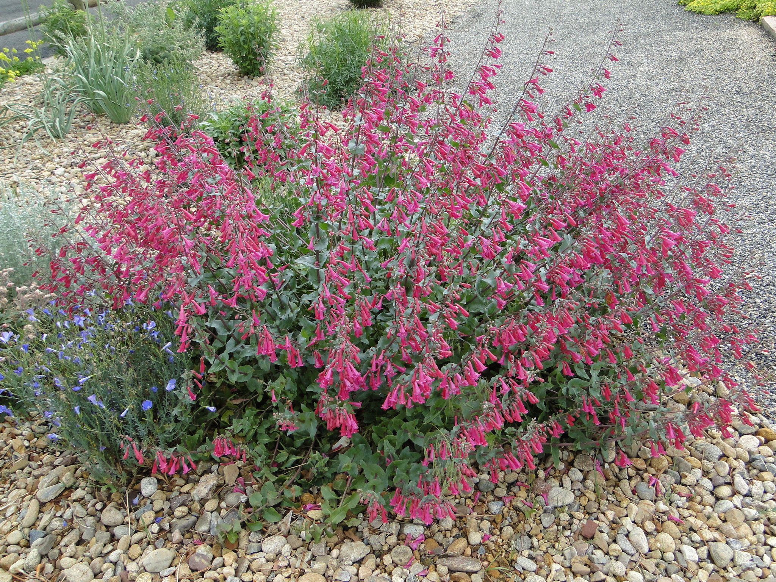
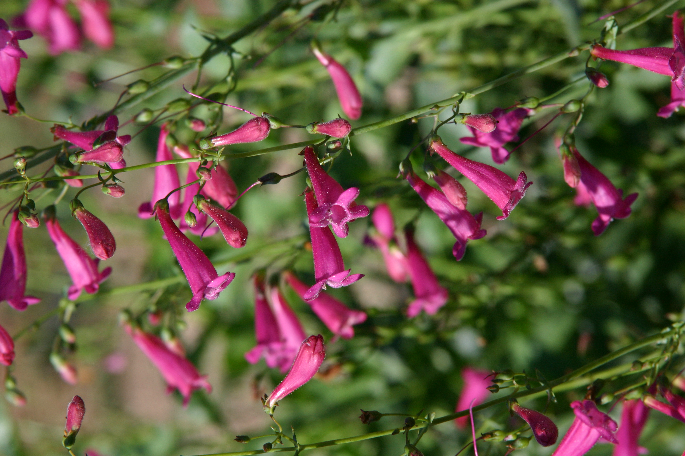
Height: 30”
Width: 15”
Blooms: May to August
Sun: Full sun to part shade
Water: Dry to Xeric best
Hardiness: USDA zones 5-9
Culture: Clay or sand, not too much humus
Recommended: 2015
Perennial
Mounds of deep blue-green, toothed foliage are topped with wands of vivid purple-magenta trumpets for much of the growing season. This long-lived perennial thrives in water-thrifty gardens where it attracts hummingbirds in daylight and hawkmoths at dusk. Nearly evergreen through mild winters: cut back in spring.

Desert Beardtongue
Penstemon pseudospectabilis
www.plantselect.org

