
Grand Mesa Beardtongue
Penstemon mensarum


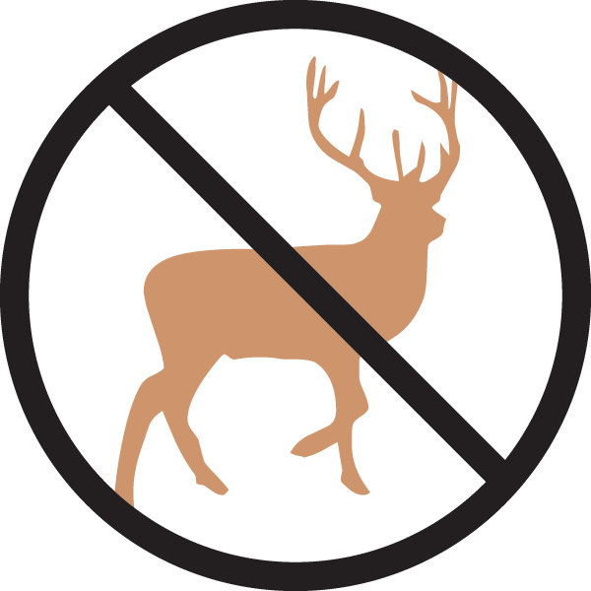




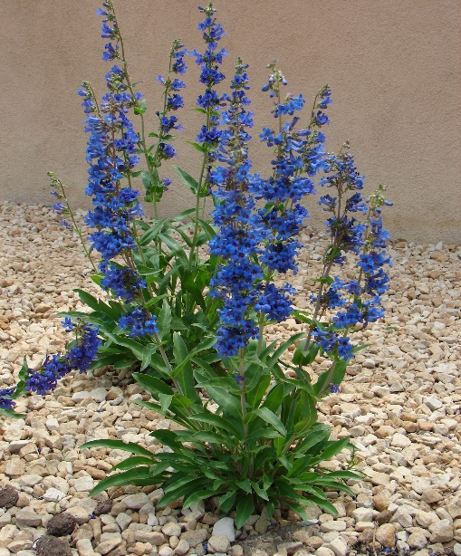

Height: 24-30 in. Width: 10-16 in.
Stunning cobalt blue spikes in early spring last for nearly two months. Dense mat of evergreen rosettes turn a lovely orange-red in winter. This close cousin to ‘Bandera’ blooms almost a month earlier, extending the season. Restricted to Western Colorado in the wild.
Culture: Clay, loam or sandy soil
Hardiness: USDA zones 4-9



WIND. HAIL. SNOW. SUN
BRING IT ON

www.plantselect.org



