

**Grand Mesa Beardtongue**

*Penstemon mensarum*

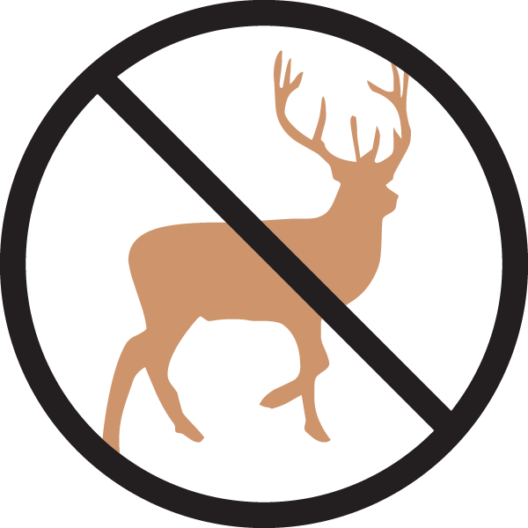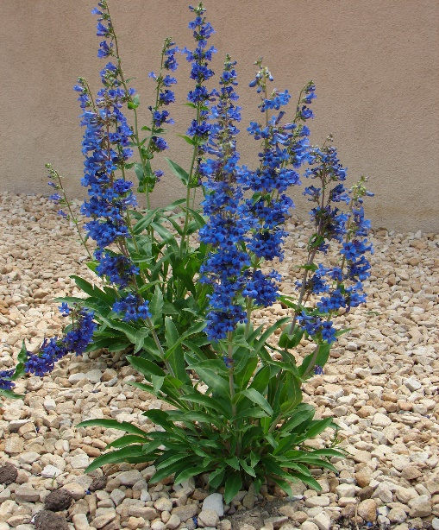

**Height: 24-30 in. Width: 10-16 in.**

Stunning cobalt blue spikes in early spring last for nearly two months. Dense mat of evergreen rosettes turn a lovely orange-red in winter. This close cousin to ‘Bandera’ blooms almost a month earlier, extending the season. Restricted to Western Colorado in the wild.

**Culture:** Clay, loam or sandy soil

**Hardiness:** USDA zones 4-9



WIND. HAIL. SNOW. SUN

**BRING IT ON**

www.plantselect.org

