



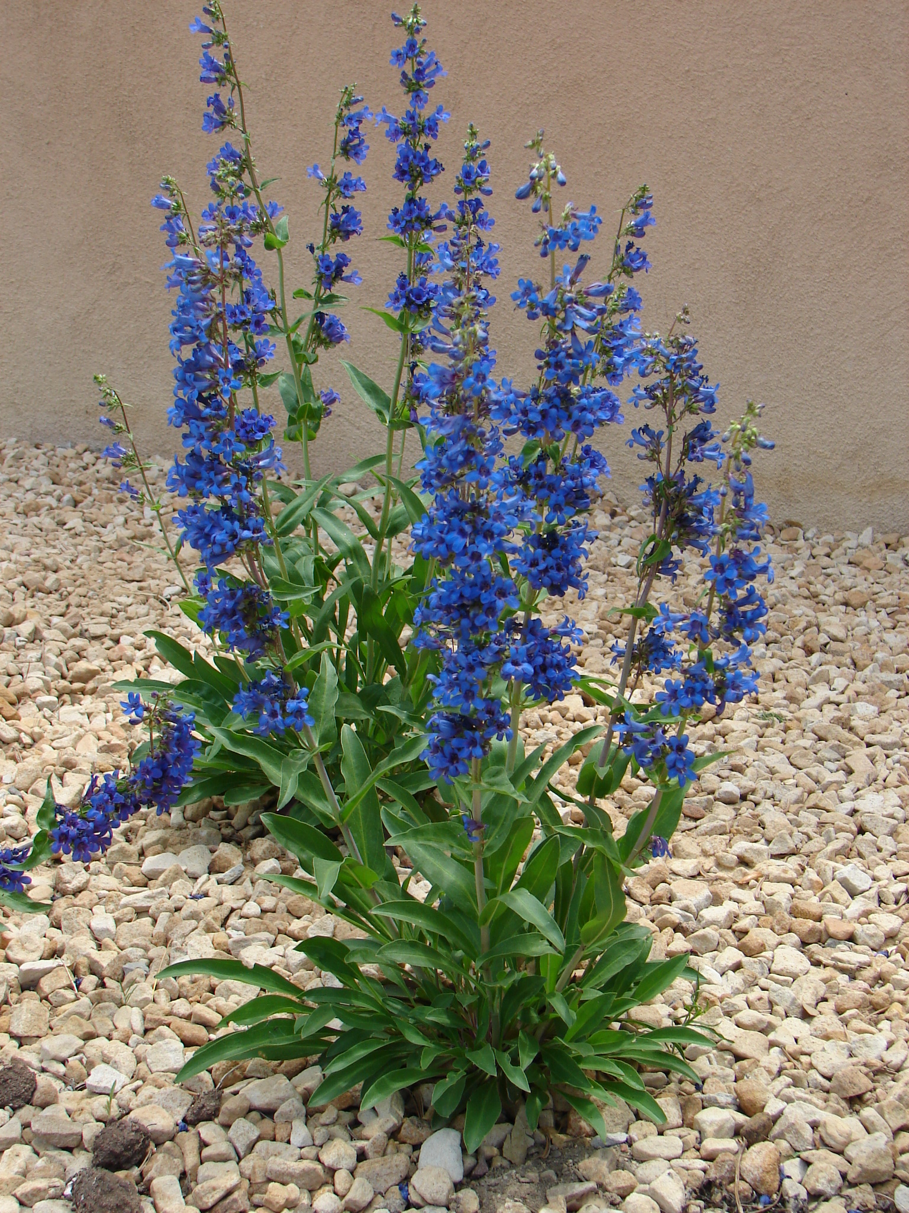
Height: 24-30”
Width: 10-15”
Blooms: April to June
Sun: Full sun to partial shade
Water: Moderate to dry
Hardiness: USDA zones 3-9 (up to 9,000’)
Culture: Clay, sandy, or loam soils
Introduced: 2011
Perennial
Stunning cobalt blue spikes in early spring last for nearly two months. Dense mat of evergreen rosettes turn a lovely orange-red in winter. This close cousin to ‘Bandera’ blooms almost a month earlier, extending the season. Restricted to Western Colorado in the wild.

Grand Mesa Beardtongue
Penstemon mensarum
www.plantselect.org

