
Silverton® Bluemat Penstemon
Penstemon linarioides var. coloradoensis

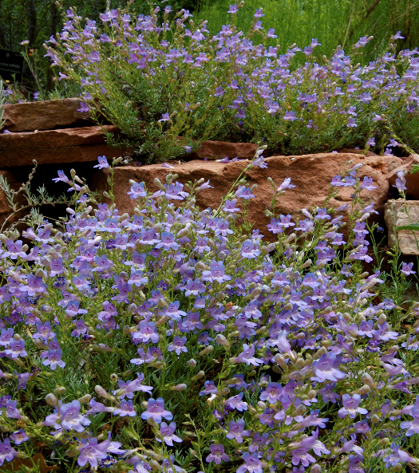








Height: 8-12 in. Width: 12-16 in.
Spreading mounds of silvery, evergreen leaves provide attractive presence year round. Lavender blue flowers are an added attraction in May and June.
Culture: Well-drained loam or sandy soil
Hardiness: USDA zones 4-10



WIND. HAIL. SNOW. SUN
BRING IT ON

www.plantselect.org



