

**Silverton® Bluemat Penstemon**

*Penstemon linarioides* var. *coloradoensis*

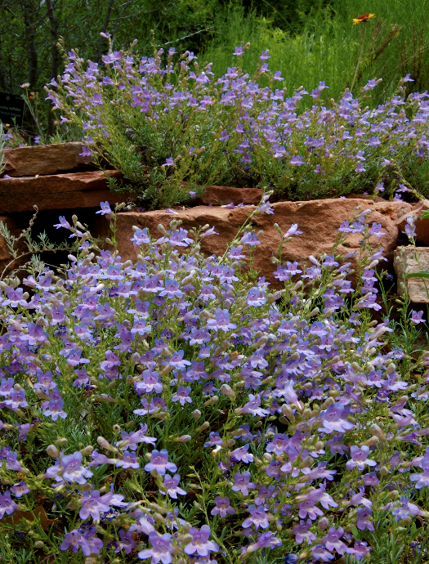

**Height: 8-12 in. Width: 12-16 in.**

Spreading mounds of silvery, evergreen leaves provide attractive presence year round. Lavender blue flowers are an added attraction in May and June.

**Culture:** Well-drainedloam or sandy soil

**Hardiness:** USDA zones 4-10



WIND. HAIL. SNOW. SUN

**BRING IT ON**

www.plantselect.org

