
Prairie Jewel® Penstemon
Penstemon grandiflorus

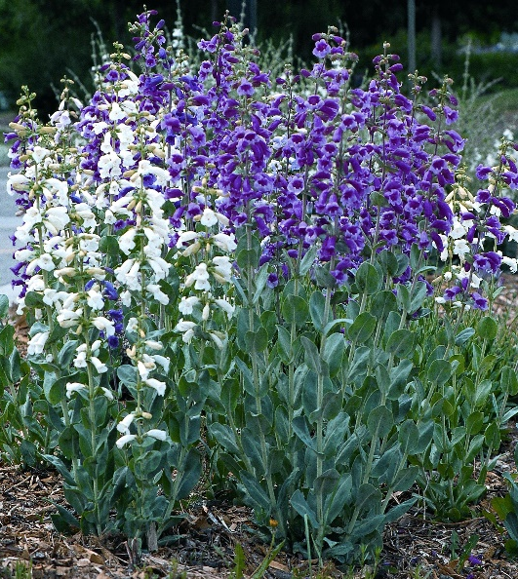






Height: 24-30 in. Width: 8-10 in.
This select strain of the showiest of the northern Great Plains’ penstemons has giant flowers that range from pure white, through lavender and rose-pink to a deep purple-violet. The silvery rosettes are attractive all year. Short-lived on wet soils, it will persist in buffalo grass or the xeriscape.
Culture: Dry loam, or sandy loam soil
Hardiness: USDA zones 3-9



WIND. HAIL. SNOW. SUN
BRING IT ON

www.plantselect.org



