

**Prairie Jewel® Penstemon**

*Penstemon grandiflorus*

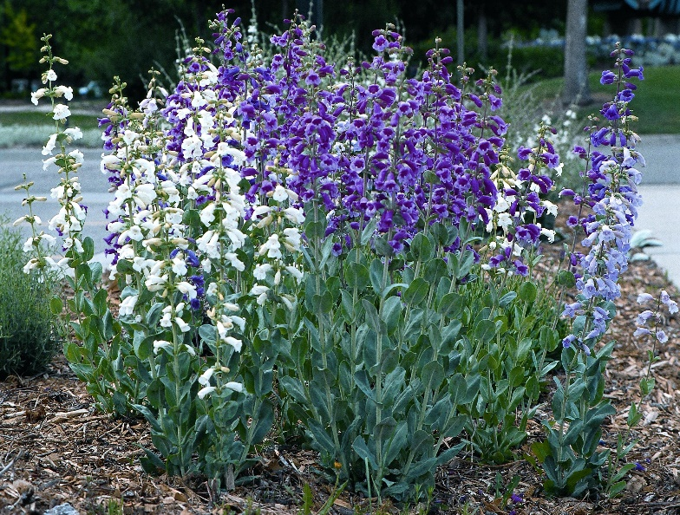

**Height: 24-30 in. Width: 8-10 in.**

This select strain of the showiest of the northern Great Plains’ penstemons has giant flowers that range from pure white, through lavender and rose-pink to a deep purple-violet. The silvery rosettes are attractive all year. Short-lived on wet soils, it will persist in buffalo grass or the xeriscape.

**Culture:** Dry loam, or sandy loam soil

**Hardiness:** USDA zones 3-9



WIND. HAIL. SNOW. SUN

**BRING IT ON**

www.plantselect.org

