



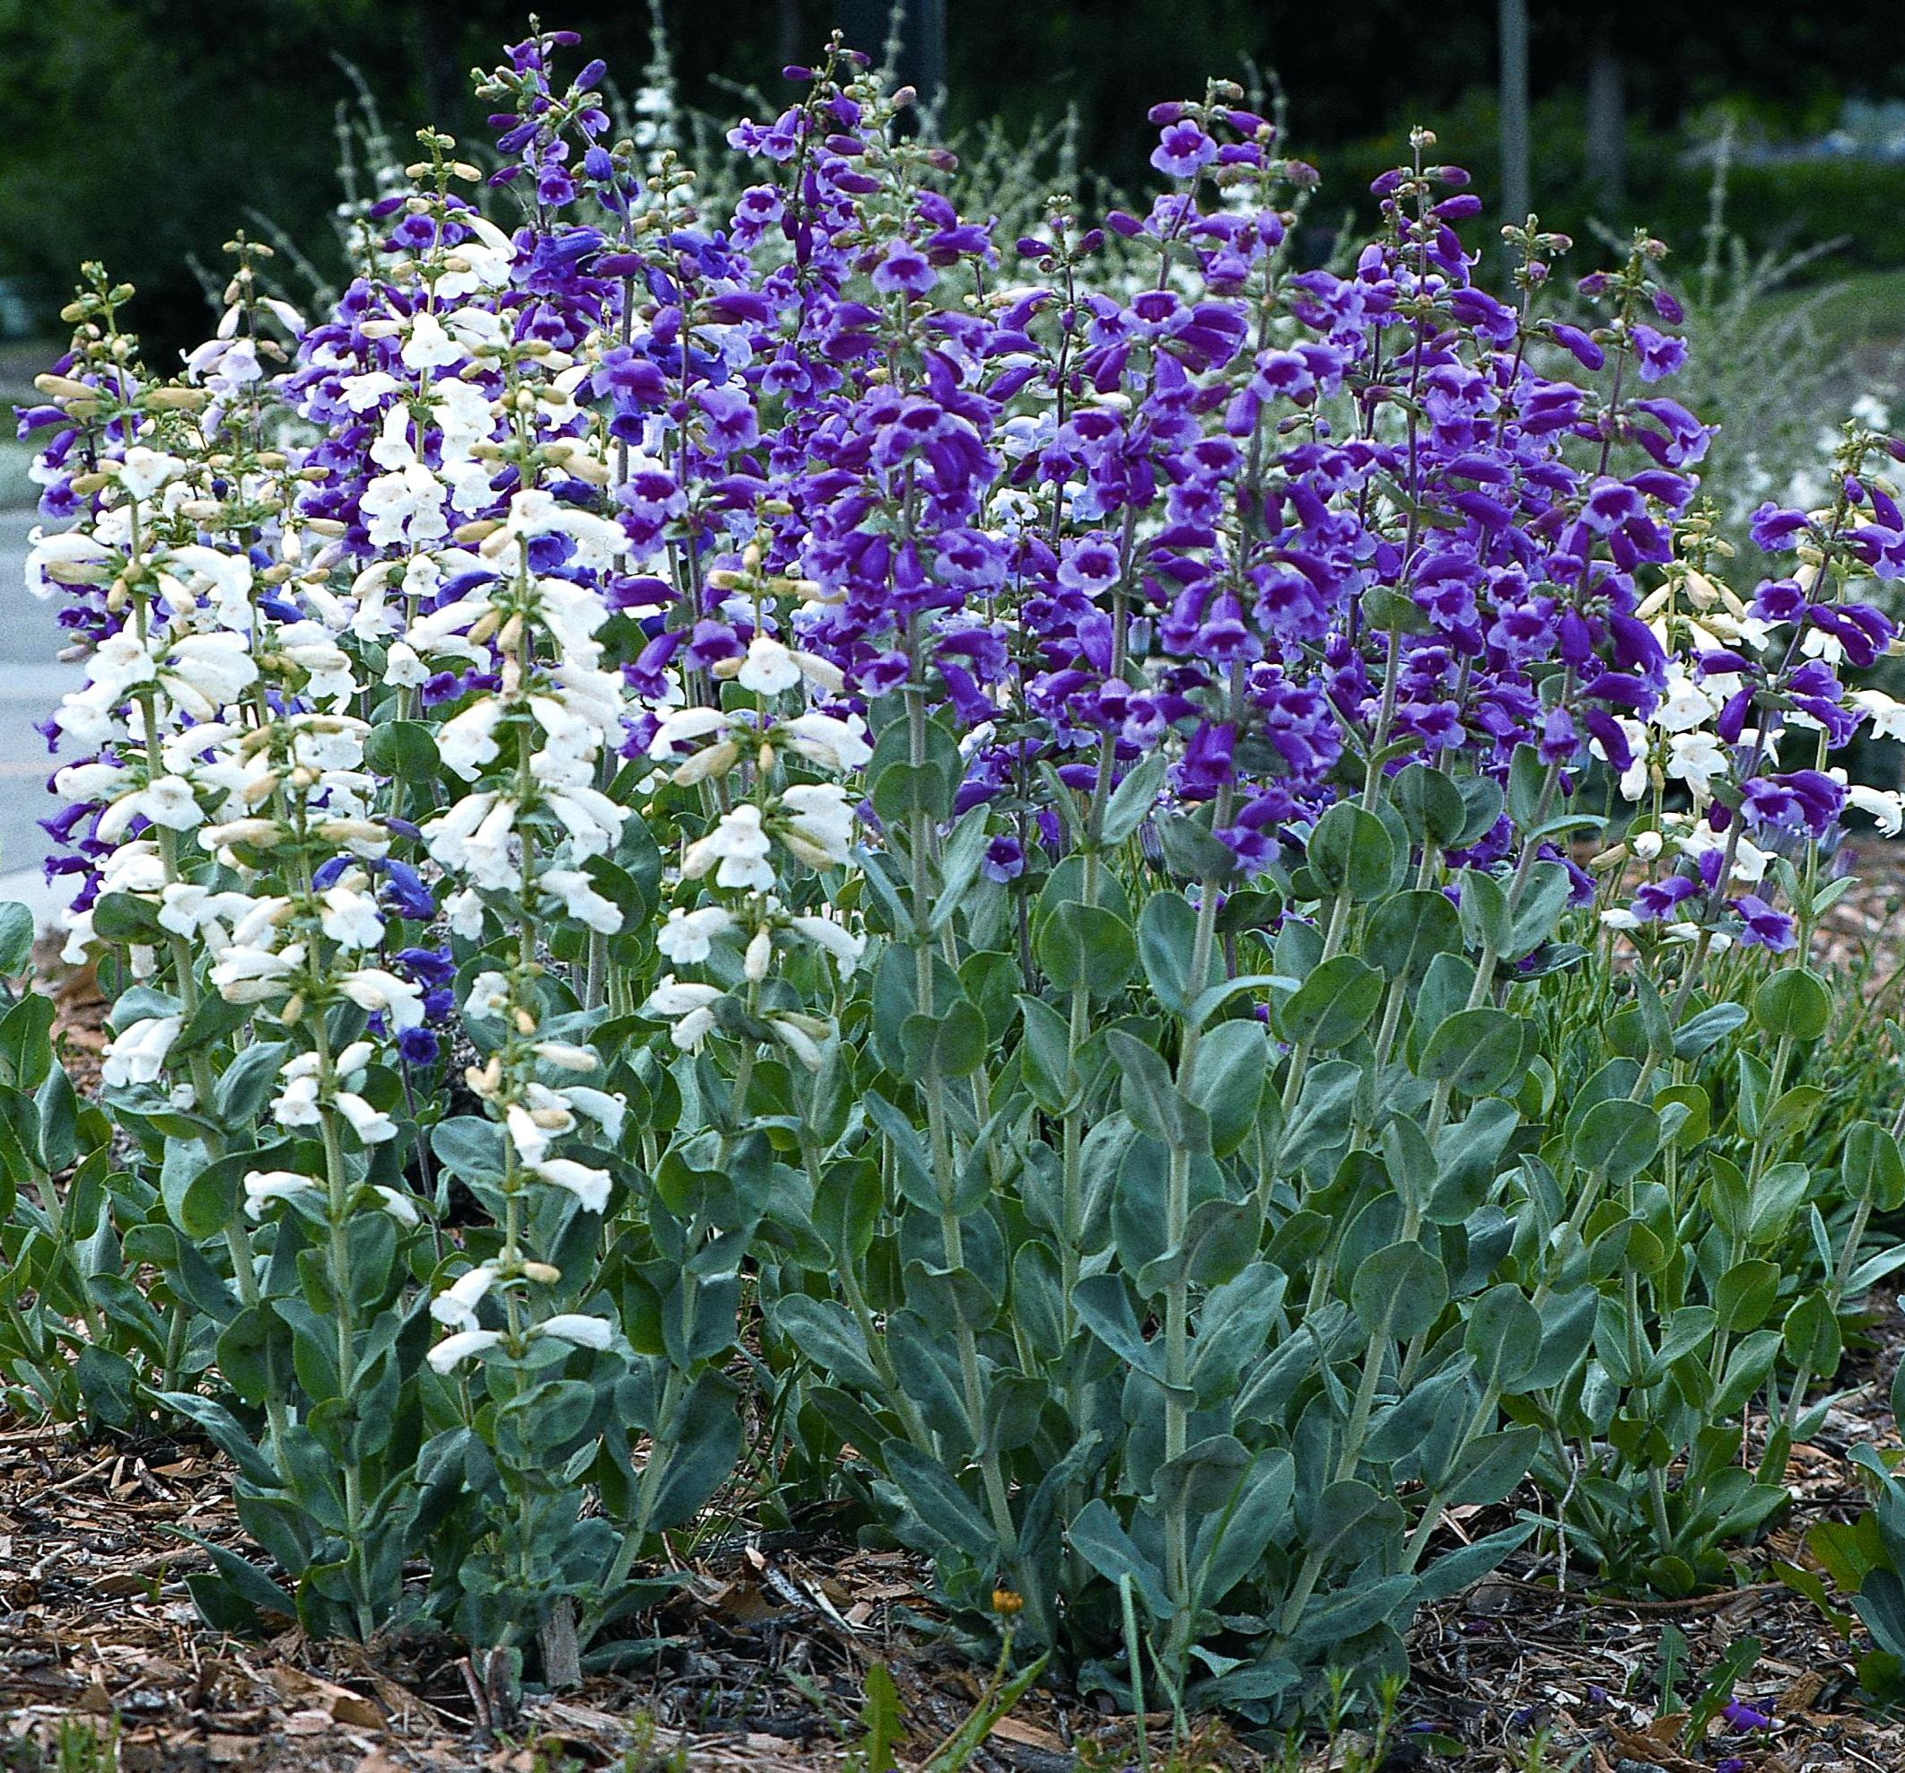
Height: 20-36”
Width: 8”
Blooms: June to July
Sun: Full sun
Water: Moderate to dry
Hardiness: USDA zones 3-9
Culture: Average soil
Introduced: 2000
Perennial
This select strain of the showiest of the northern Great Plains’ penstemons was developed from the Seeba hybrids by Mary Ann Heacock of Denver. It has giant flowers that range from pure white, through lavender and rose-pink to a deep purple-violet. The silvery rosettes are attractive all year. Short-lived on wet soils, it will persist in buffalo grass or the xeriscape.

Prairie Jewel® Penstemon
Penstemon grandiflorus
www.plantselect.org

