



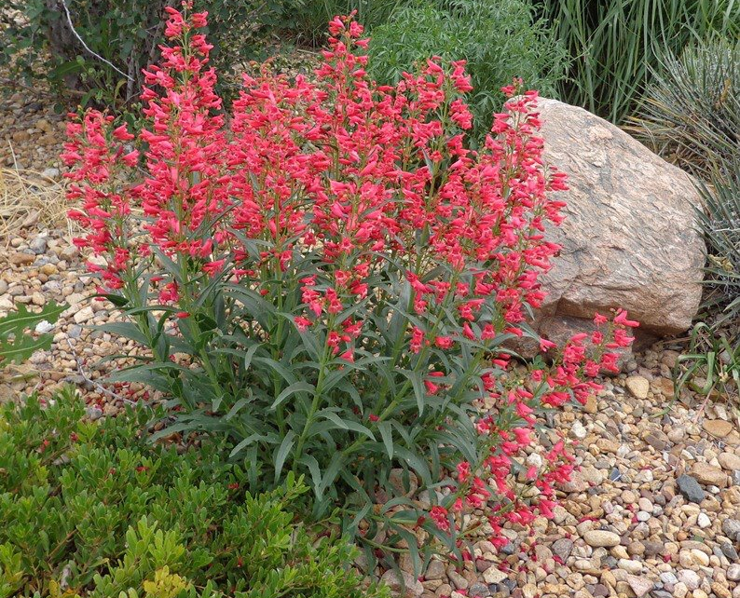
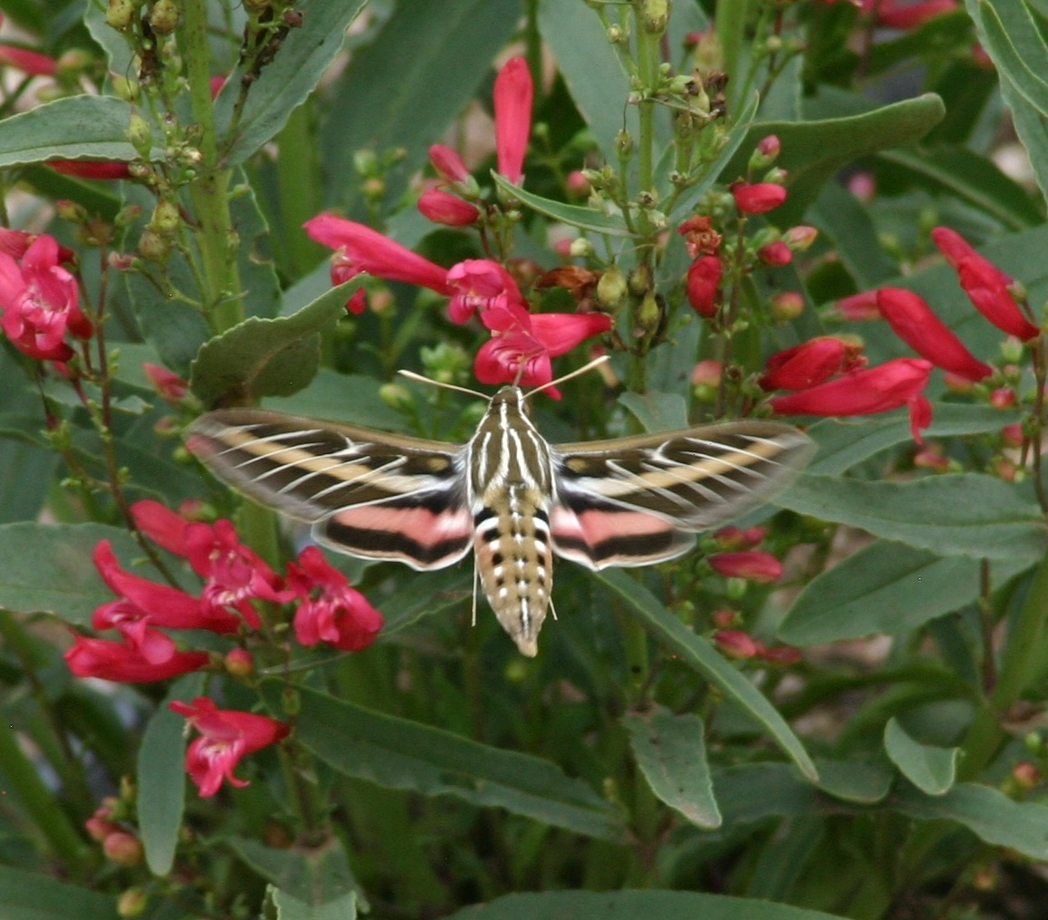
Height: 15-18”
Width: 12”
Blooms: Coral pink, May-July
Sun: Full sun
Water: Moderate to dry
Hardiness: USDA zones 5-8
Culture: Sandy, well-drained soil
Recommended: 2015
Perennial
Coral Baby penstemon sports bouquets of coral-pink flowers from May to July. The upright flower spikes are beautiful in dry borders, rock gardens, or containers. Great perennial companion to LITTLE TRUDY® catmint and FIRE SPINNER® ice plant. Coral Baby is a favorite of many pollinators and provides years of enjoyment.

Coral Baby Penstemon
Penstemon barbatus ‘Coral Baby’
www.plantselect.org

