


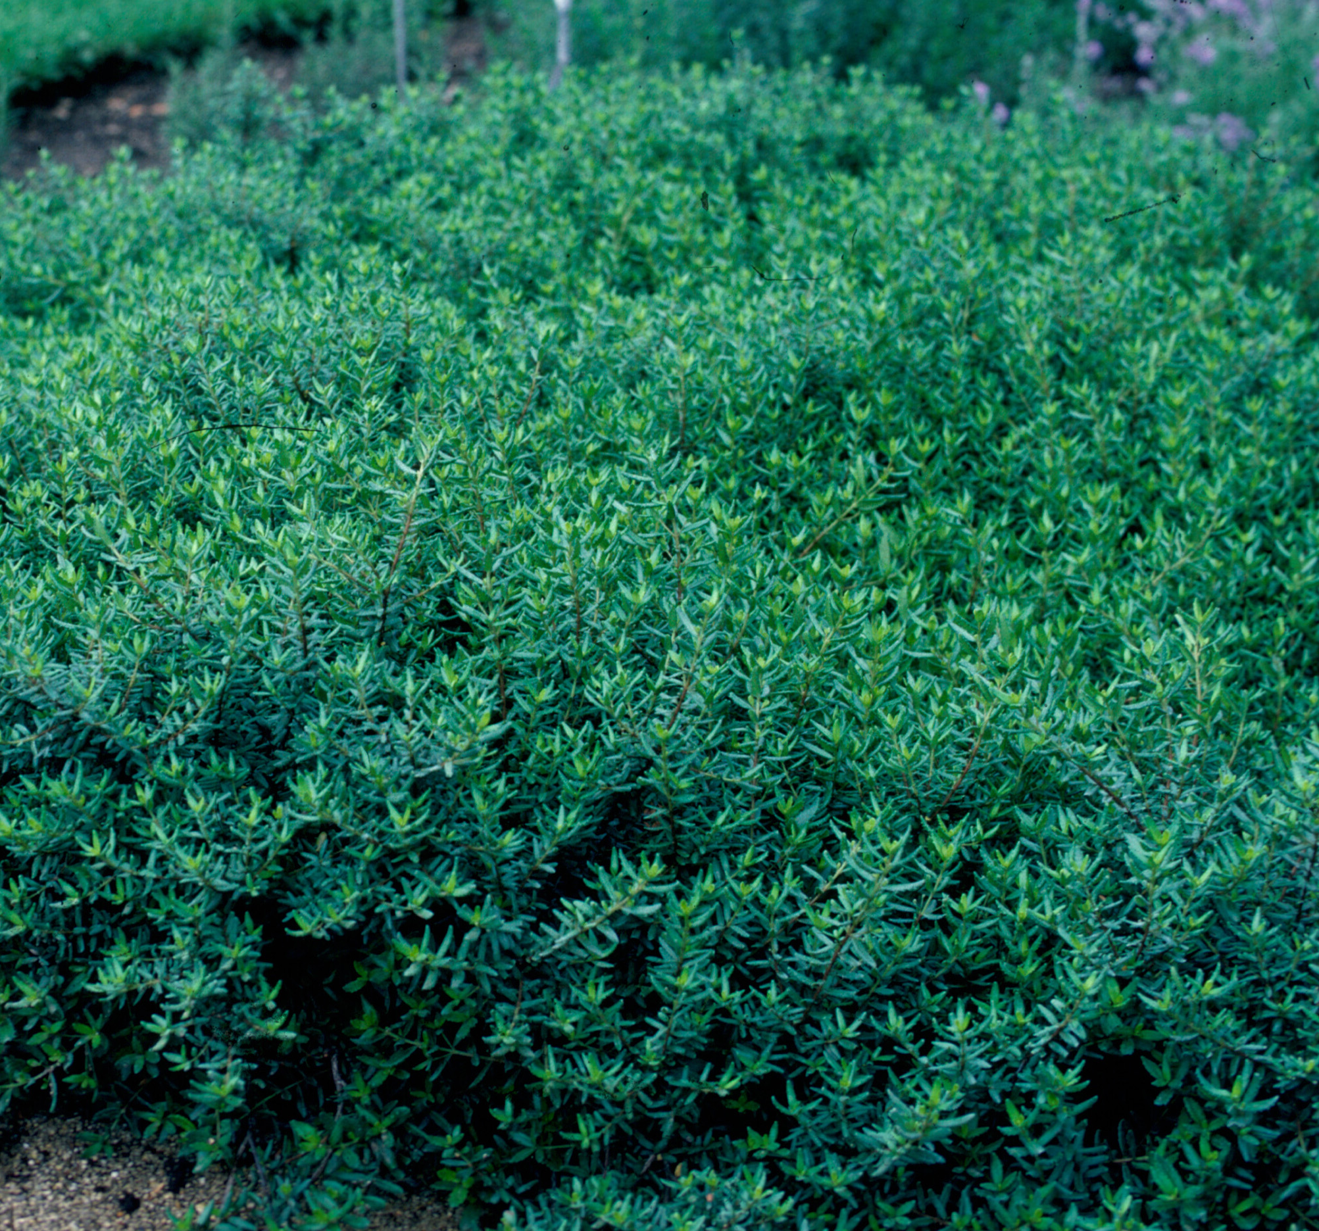
Height: 8-12”
Width: 15-20”
Blooms: Inconspicuous flowers in April
Sun: Partial shade to full shade
Water: Moderate
Hardiness: USDA zones 4-9
Culture: Average soil
Introduced: 2003
Shrub
A prostrate, broadleaf evergreen shrub. The purple lustrous, dark green leaves deepen with purple tints in the winter. Although rare in its native Allegheny Mountains’ home, this is a durable and adaptable plant for edging or small-scale groundcover in the home garden.

Mountain Lover
Paxistima canbyi
www.plantselect.org

