
Mountain Lover
Paxistima canbyi

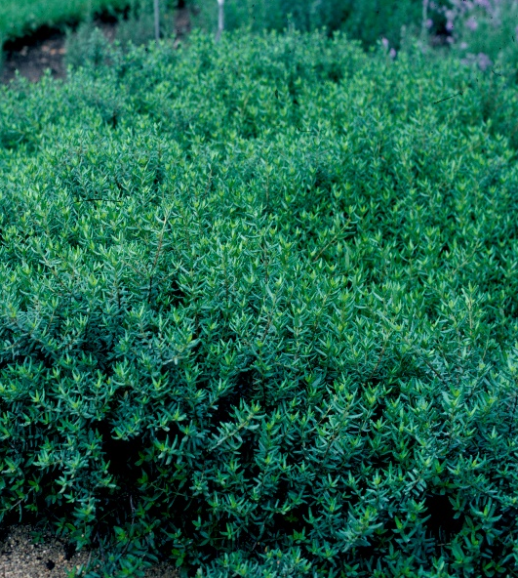





Height: 8-12 in. Width: 15-20 in.
A prostrate, broadleaf evergreen shrub. The purple lustrous, dark green leaves deepen with purple tints in the winter. Although rare in its native Allegheny Mountains’ home, this is a durable and adaptable plant for edging or small-scale groundcover in the home garden.
Culture: Loam soil
Hardiness: USDA zones 4-9



WIND. HAIL. SNOW. SUN
BRING IT ON

www.plantselect.org



