

**Mountain Lover**

*Paxistima canbyi*

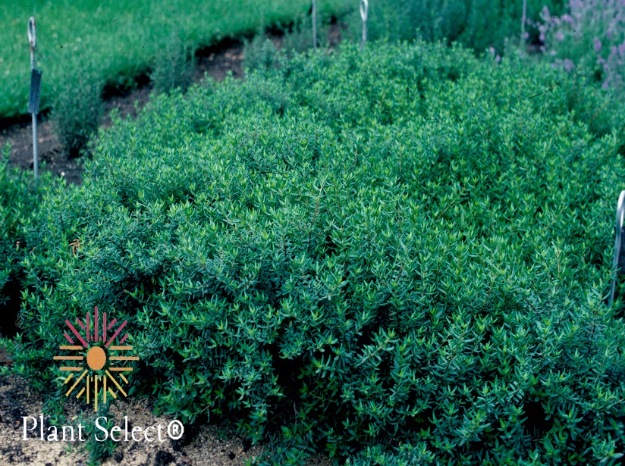

**Height: 8-12 in. Width: 15-20 in.**

A prostrate, broadleaf evergreen shrub. The purple lustrous, dark green leaves deepen with purple tints in the winter. Although rare in its native Allegheny Mountains’ home, this is a durable and adaptable plant for edging or small-scale groundcover in the home garden.

**Culture:** Loam soil

**Hardiness:** USDA zones 4-9



WIND. HAIL. SNOW. SUN

**BRING IT ON**

www.plantselect.org

