
Lavender Mist® Sun Daisy
Osteospermum sp. ‘P006S’

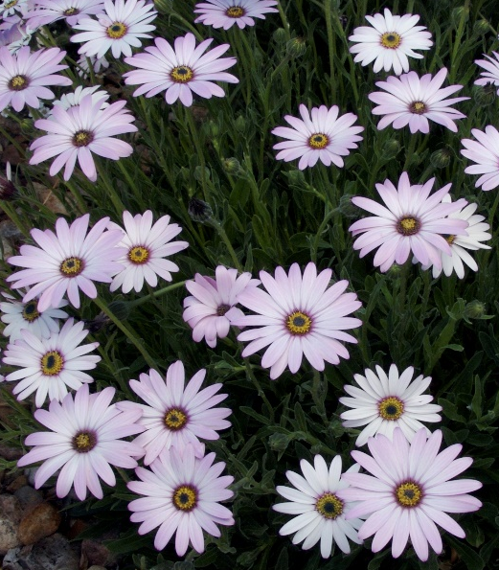



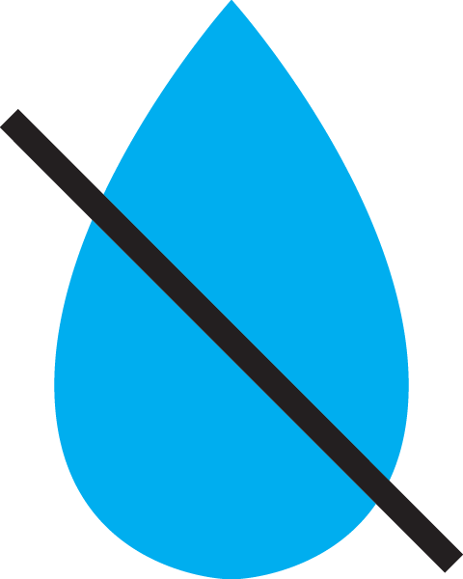

Height: 12-14 in. Width: 14-18 in.
Plant has neat mats of oblong, nearly succulent leaves which are evergreen. Its three-inch flower heads are produced from April to autumn, opening white and turning a soft lavender-purple as they age.
Culture: Loam
Hardiness: USDA zones 4b-8



WIND. HAIL. SNOW. SUN
BRING IT ON

www.plantselect.org



