

**Lavender Mist® Sun Daisy**

*Osteospermum sp. ‘P006S’*

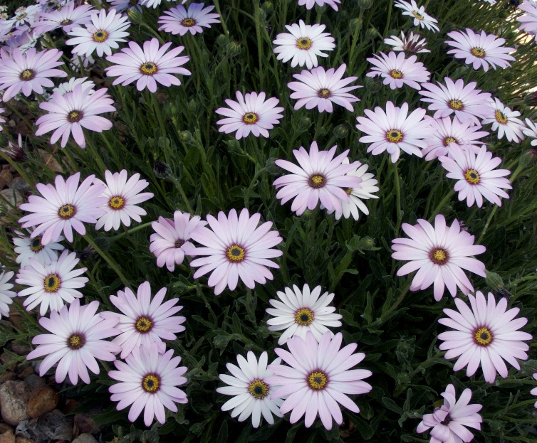

**Height: 12-14 in. Width: 14-18 in.**

Plant has neat mats of oblong, nearly succulent leaves which are evergreen. Its three-inch flower heads are produced from April to autumn, opening white and turning a soft lavender-purple as they age.

**Culture:** Loam

**Hardiness:** USDA zones 4b-8



WIND. HAIL. SNOW. SUN

**BRING IT ON**

www.plantselect.org

