

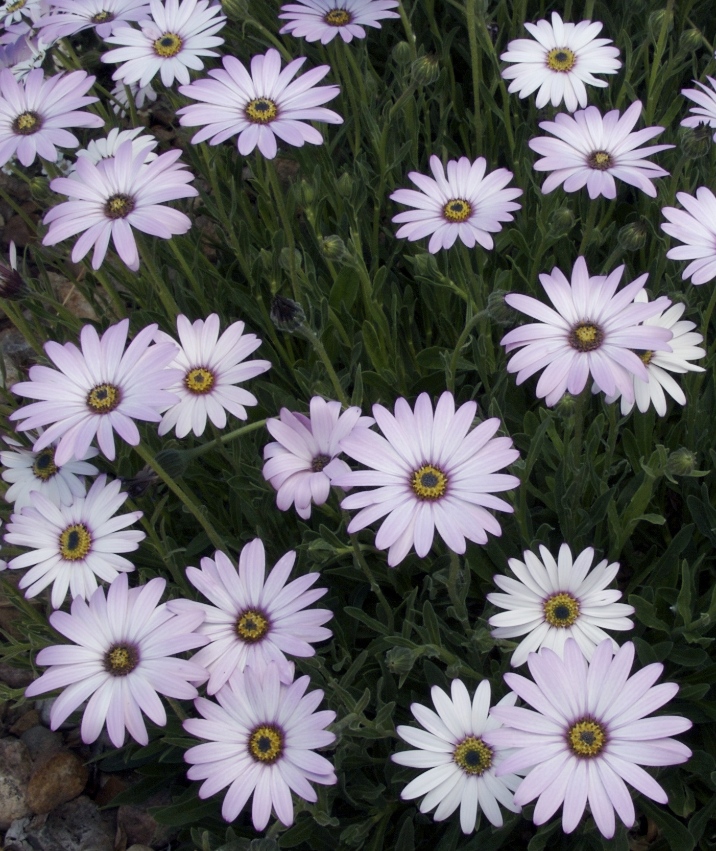
Height: 12”
Width: 15”
Blooms: April to fall
Sun: Full sun to partial shade
Water: Moderate
Hardiness: USDA zones 4b-8
Culture: Garden loam
Introduced: 1998
Perennial
Plant has neat mats of oblong, nearly succulent leaves which are evergreen. Its three-inch flower heads are produced from April to autumn, opening white and turning a soft lavender-purple as they age.

Lavender Mist® Sun Daisy
Osteospermum sp.
www.plantselect.org

