

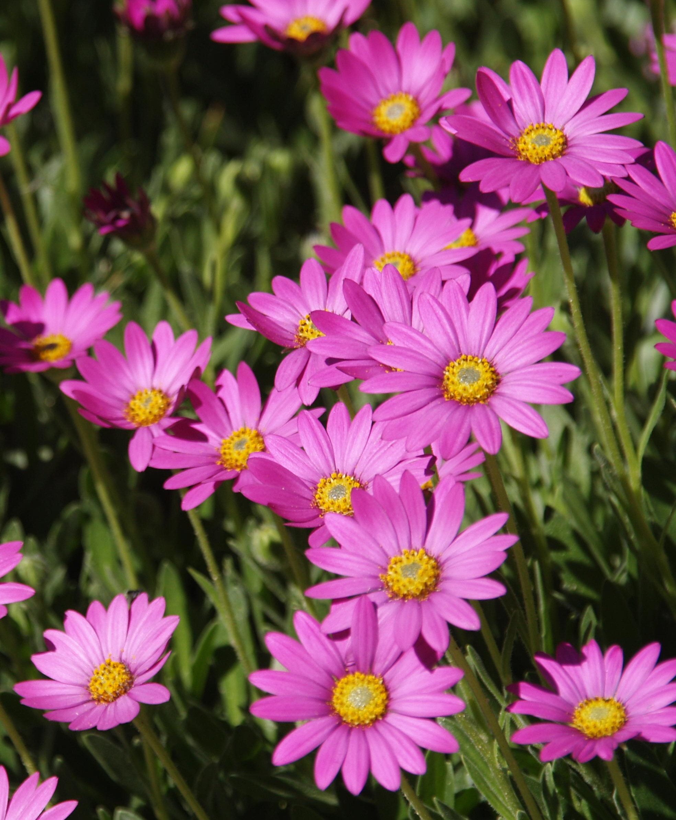
Height: 10”
Width: 12”
Blooms: April to midsummer
Sun: Full sun to partial shade
Water: Moist to moderate
Hardiness: USDA zones 4b-9
Culture: Ordinary soil
Introduced: 1998
Perennial
Bright purple daisies completely cover the trim mat of rich green leaves from late April to midsummer. With deadheading, it blooms sparingly until frost. A dazzling wild flower from the summits of the Drakensburg Mountains in South Africa.

Purple Mountain® Sun Daisy
Osteospermum barberiae var. compactum
www.plantselect.org

