
Purple Mountain® Sun Daisy
Osteospermum barberiae var. compactum






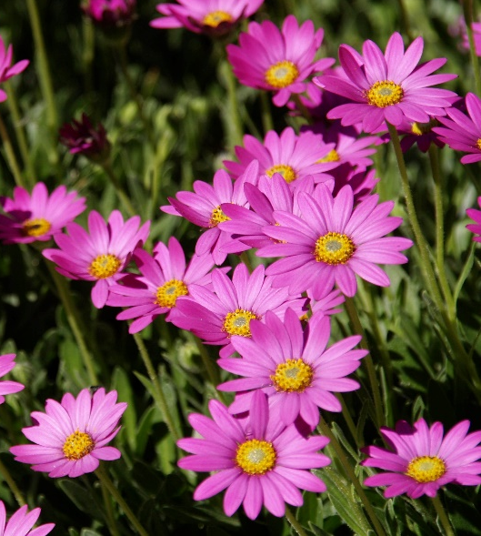

Height: 10-12 in. Width: 12-14 in.
Bright purple daisies completely cover the trim mat of rich green leaves from late April to midsummer. With deadheading, it blooms sparingly until frost. A dazzling wild flower from the summits of the Drakensburg Mountains in South Africa.
Culture: Loam
Hardiness: USDA zones 4b-9



WIND. HAIL. SNOW. SUN
BRING IT ON

www.plantselect.org



