

**Purple Mountain® Sun Daisy**

*Osteospermum barberiae var. compactum*

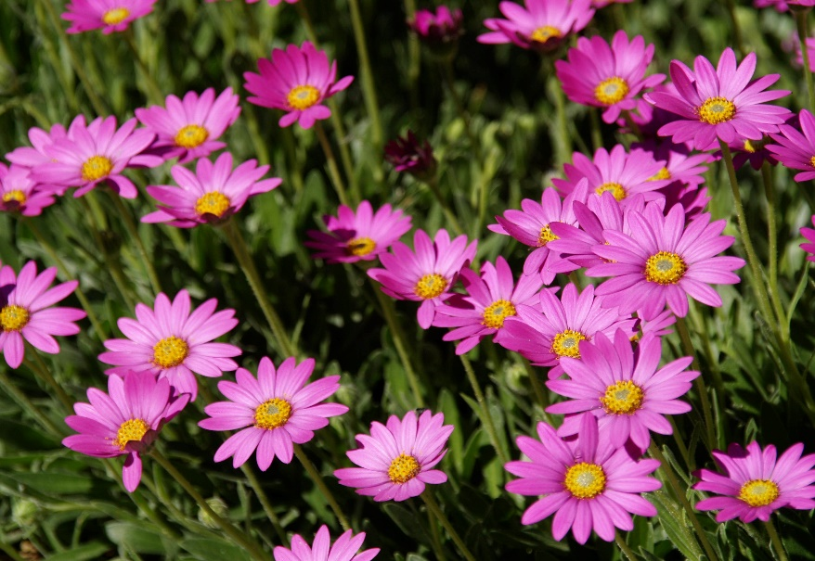

**Height: 10-12 in. Width: 12-14 in.**

Bright purple daisies completely cover the trim mat of rich green leaves from late April to midsummer. With deadheading, it blooms sparingly until frost. A dazzling wild flower from the summits of the Drakensburg Mountains in South Africa.

**Culture:** Loam

**Hardiness:** USDA zones 4b-9



WIND. HAIL. SNOW. SUN

**BRING IT ON**

www.plantselect.org

