

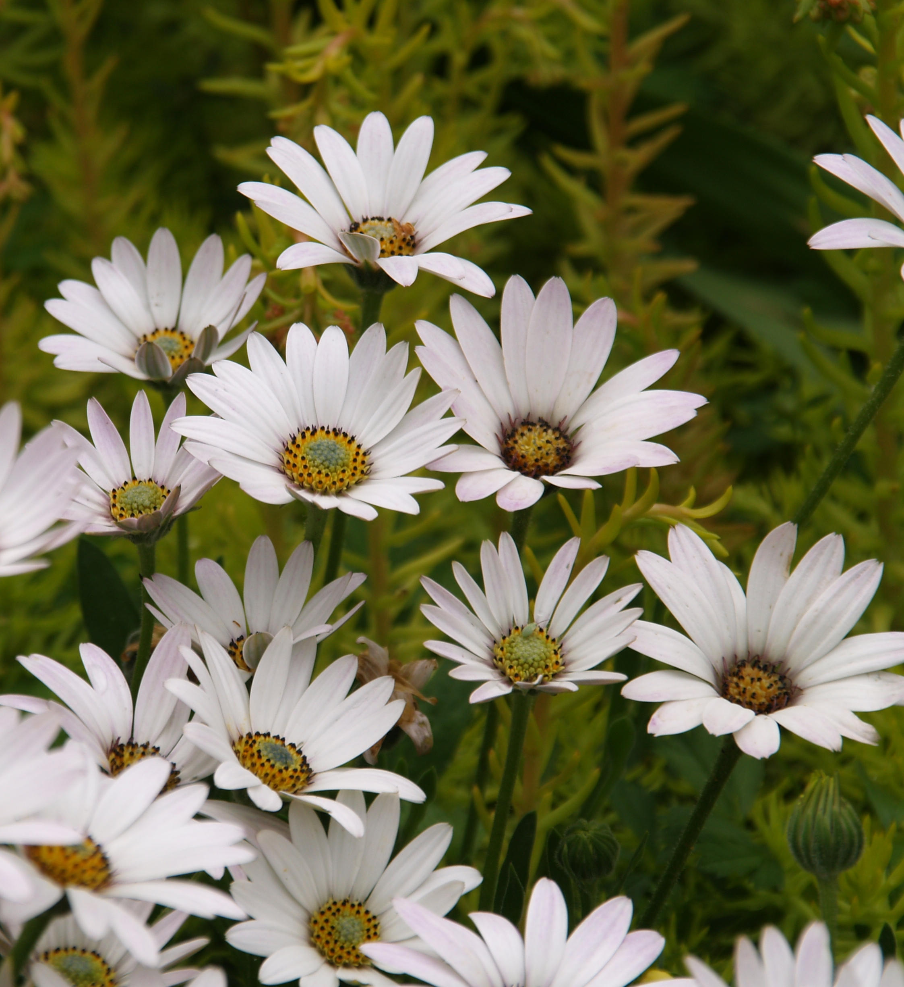
Height: 8-12”
Width: 10-15”
Blooms: April to late summer
Sun: Full sun to partial shade
Water: Moderate to dry
Hardiness: USDA zones 4-9 (up to 9,000’)
Culture: Clay, sandy, or loam soils
Introduced: 2011
Perennial
Dazzling white flowers with metallic backing are produced from April through summer over glistening mats of lustrous, nearly succulent, evergreen foliage. It has greater disease resistance and heavier summer bloom than the other hardy sun daisies. Giant blossoms close at night to reveal a metallic reverse of ray flowers. A spectacular addition to a sunny border or xeriscape garden.

Avalanche White Sun Daisy
Osteospermum ‘Avalanche’ ^{PP22,705}
www.plantselect.org

