

**Avalanche White Sun Daisy**

*Osteospermum* ‘Avalanche’ PP22,705

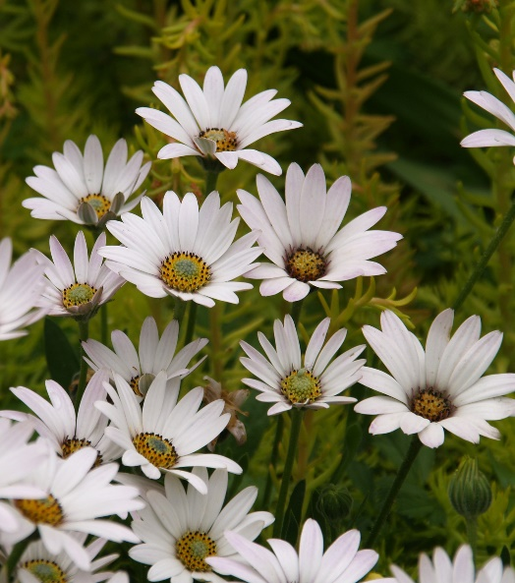

**Height: 8-12 in. Width: 24-36 in.**

Dazzling white flowers with metallic backing are produced from April through summer over glistening mats of lustrous, nearly succulent, evergreen foliage. Giant blossoms close at night to reveal a metallic reverse of ray flowers.

**Culture:** Clay, loam or sandy soil

**Hardiness:** USDA zones 4-9



WIND. HAIL. SNOW. SUN

**BRING IT ON**

www.plantselect.org

