

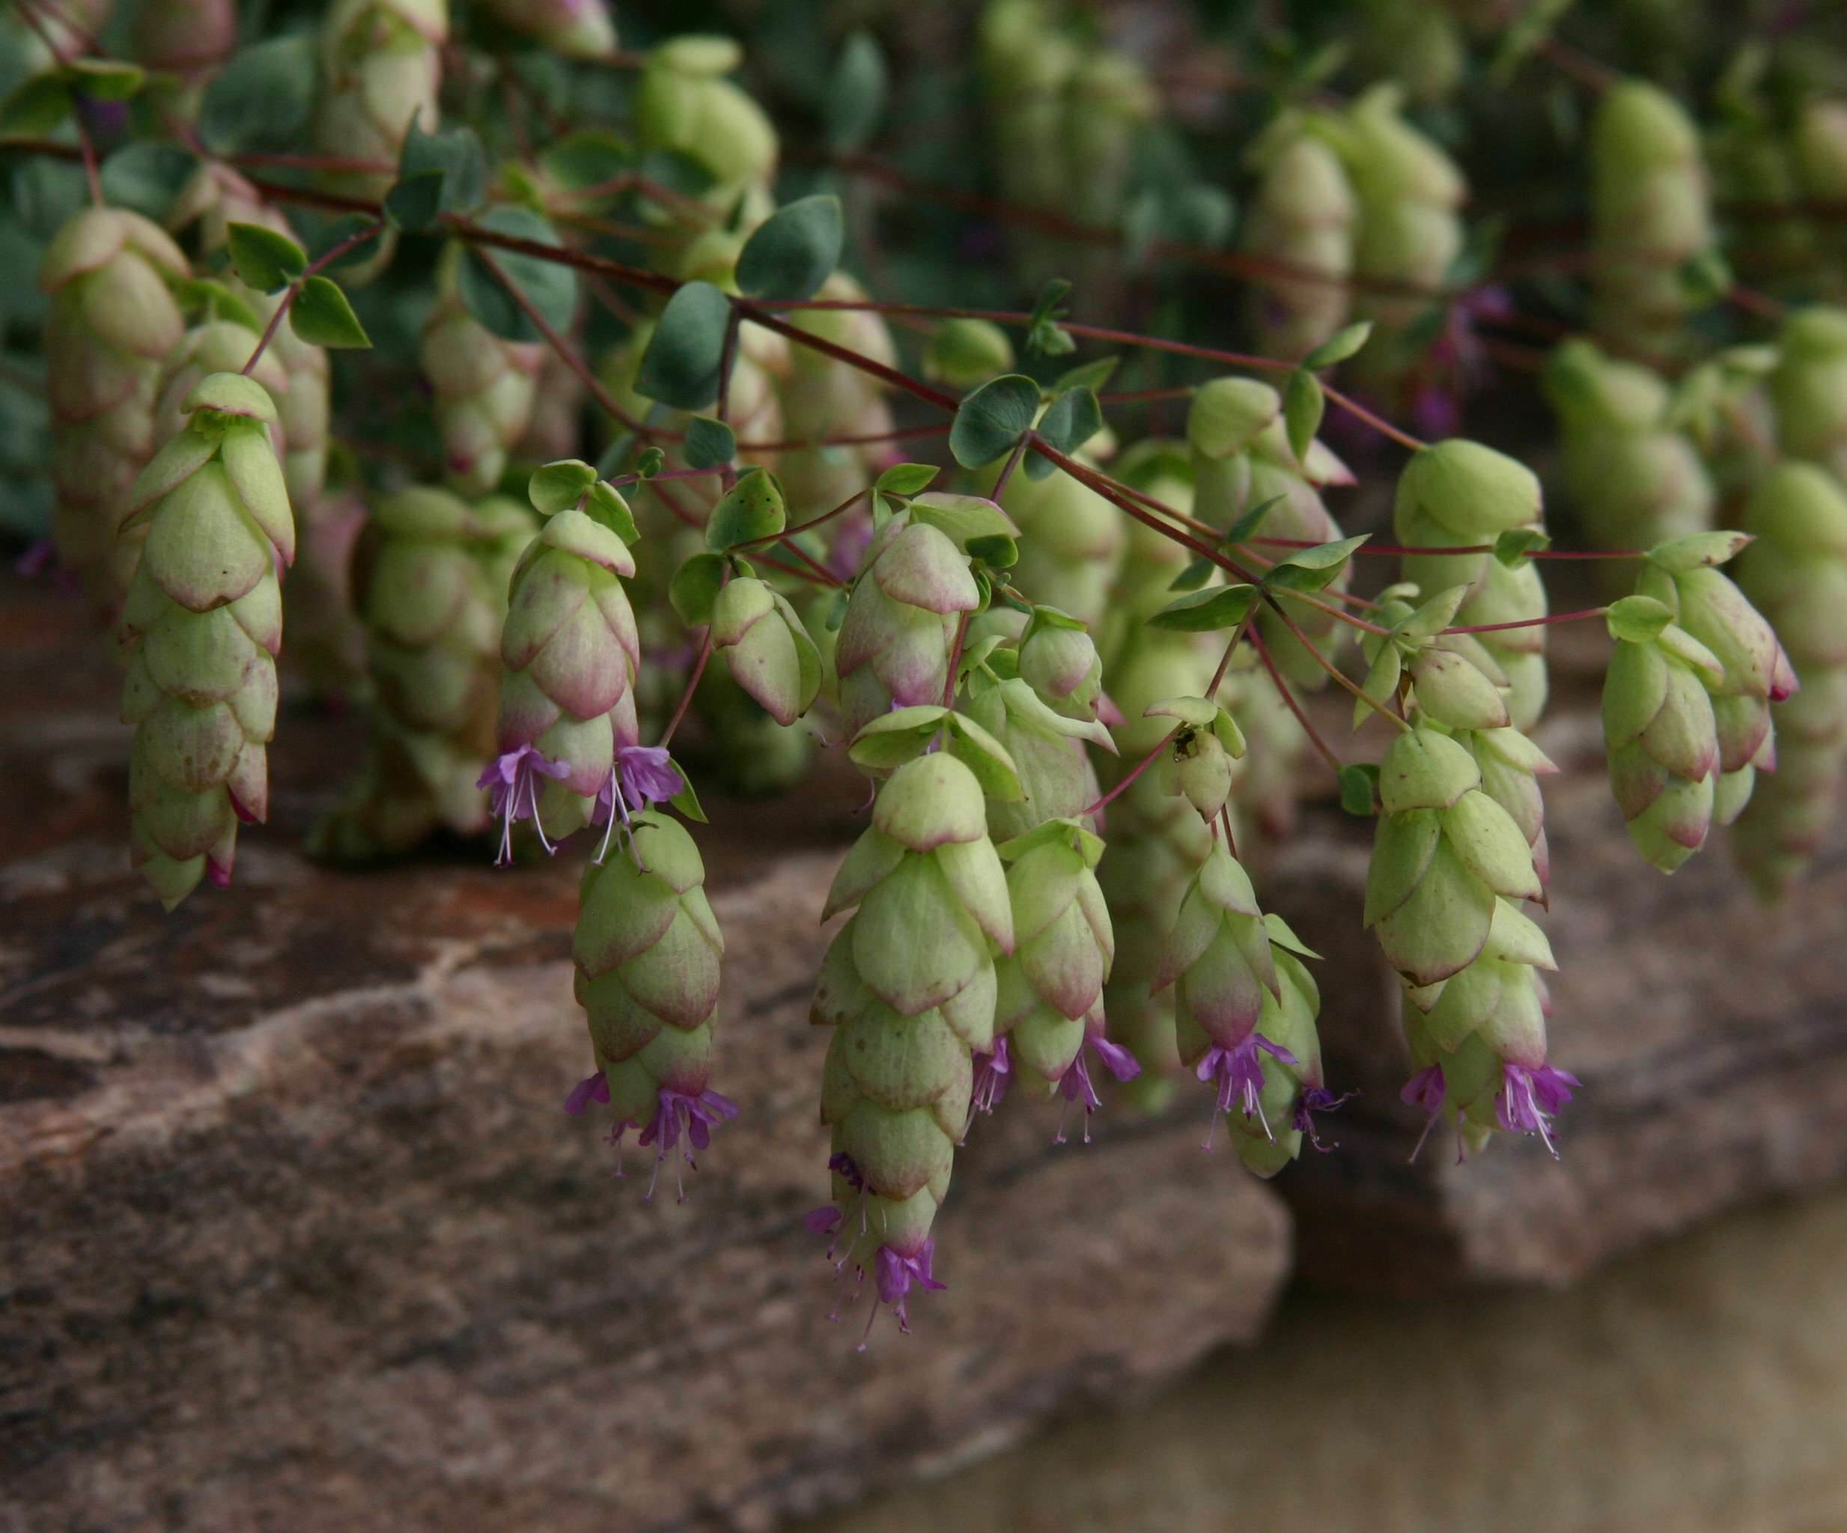
Height: 10-15”
Width: 18-24”
Blooms: Summer to fall
Sun: Full sun to partial shade
Water: Moderate
Hardiness: USDA zones 4b-8
Culture: Average, clay, or sandy soil; well-draining
Introduced: 2004
Perennial
Vigorous, trailing herb with hop-like bracts of lavender and chartreuse through the summer months, turning brown and dry in autumn. Looks best when cascading over a raised bed, rock garden, or container.

Hopflower Oregano
Origanum libanoticum
www.plantselect.org

