
Hopflower Oregano
Origanum libanoticum

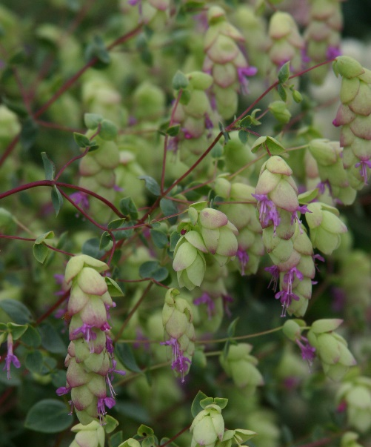

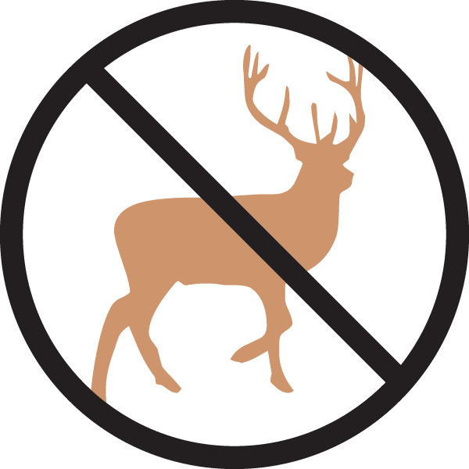





Height: 10-15 in. Width: 18-24 in.
Vigorous, trailing herb with hop-like bracts of lavender and chartreuse through the summer months, turning brown and dry in autumn. Looks best when cascading over a raised bed, rock garden, or container.
Culture: Clay, loam, or sandy soil
Hardiness: USDA zones 4-8



WIND. HAIL. SNOW. SUN
BRING IT ON

www.plantselect.org



