

**Hopflower Oregano**

*Origanum libanoticum*

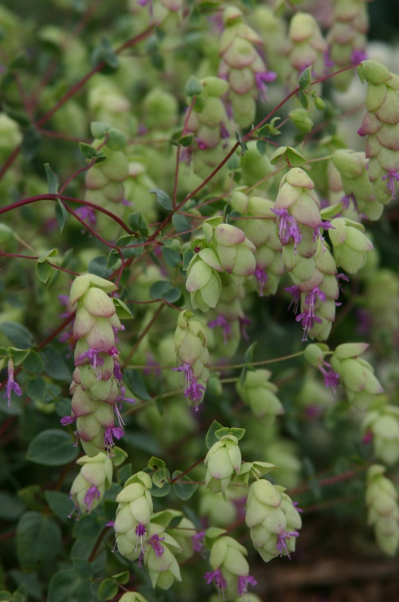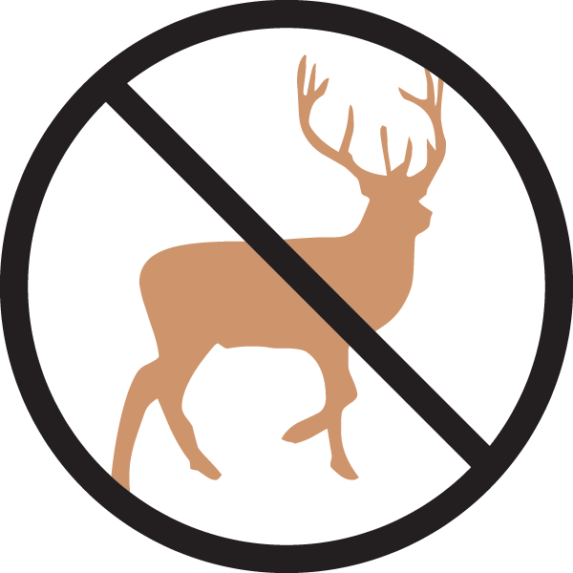

**Height: 10-15 in. Width: 18-24 in.**

Vigorous, trailing herb with hop-like bracts of lavender and chartreuse through the summer months, turning brown and dry in autumn. Looks best when cascading over a raised bed, rock garden, or container.

**Culture:** Clay, loam, or sandy soil

**Hardiness:** USDA zones 4-8



WIND. HAIL. SNOW. SUN

**BRING IT ON**

www.plantselect.org

