



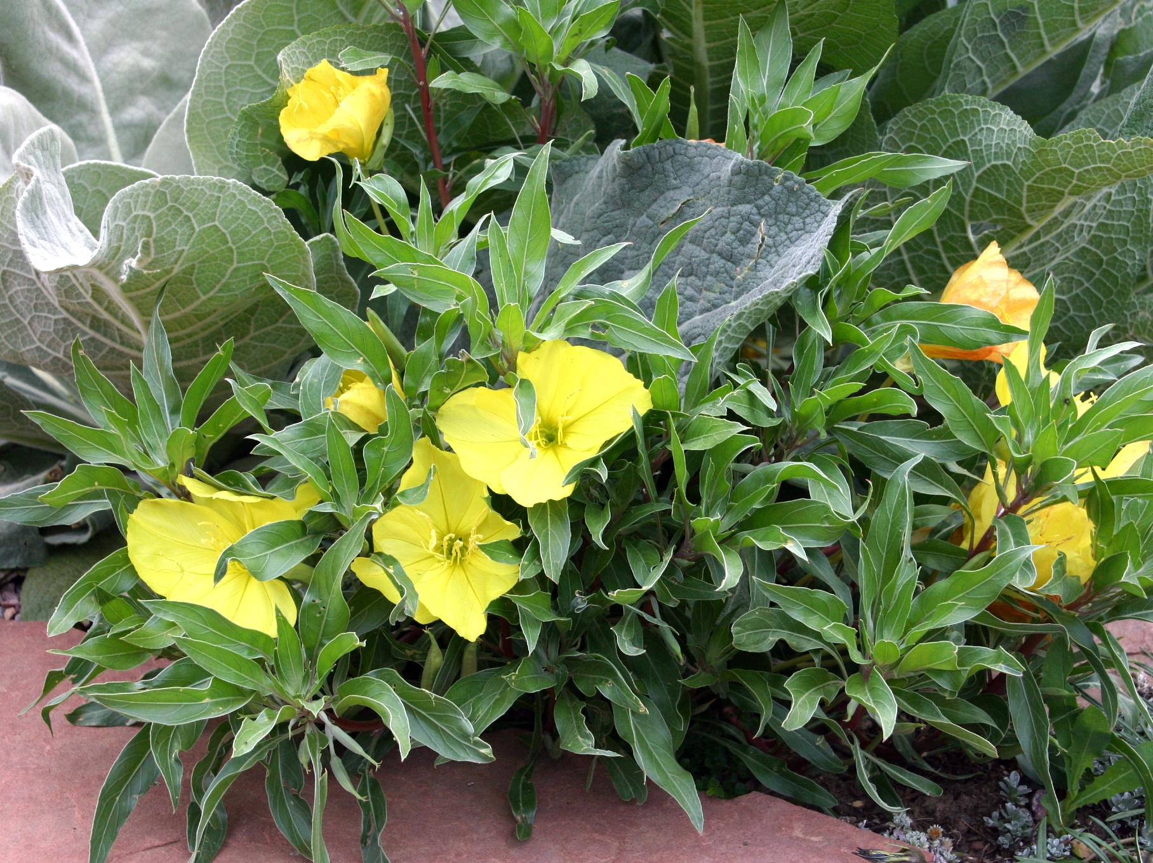
Height: 4”
Width: 14”
Blooms: May to frost
Sun: Full sun
Water: Moderate to dry; not too wet
Hardiness: USDA zones 4a-9
Culture: Average soil
Introduced: 1999
Perennial
A southern Great Plains endemic introduced by James Locklear, further promoted by Bluebird Nursery, Clarkson, Nebraska. Silver leaves compliment the clear yellow flowers. Best on well-drained sites. Blooms May to frost. Drought tolerant.

Silver Blade® Evening Primrose
Oenothera macrocarpa subsp. incana
www.plantselect.org

