
Silver Blade® Evening Primrose
Oenothera macrocarpa subsp. incana







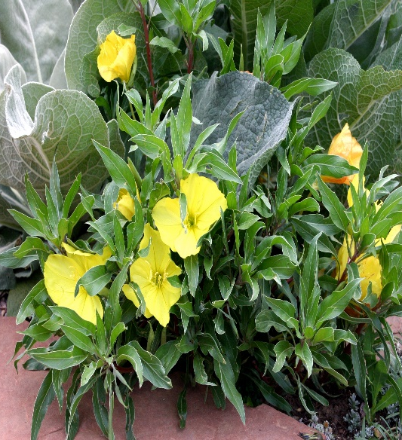

Height: 4-6 in. Width: 14-18 in.
Silver leaves compliment the clear yellow flowers of this southern Great Plains endemic. Promoted by Bluebird Nursery, Clarkson, Nebraska. Blooms May to frost.
Culture: Well-drained loam soil
Hardiness: USDA zones 4a-9



WIND. HAIL. SNOW. SUN
BRING IT ON

www.plantselect.org



