

**Silver Blade® Evening Primrose**

*Oenothera macrocarpa subsp. incana*

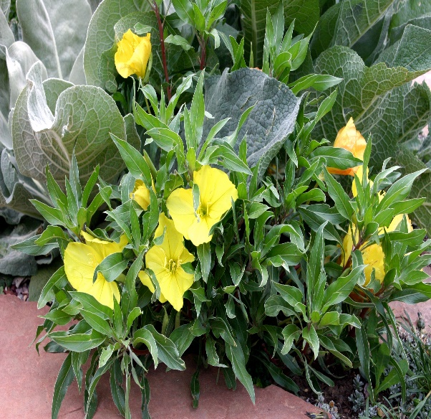

**Height: 4-6 in. Width: 14-18 in.**

Silver leaves compliment the clear yellow flowers of this southern Great Plains endemic. Promoted by Bluebird Nursery, Clarkson, Nebraska. Blooms May to frost.

**Culture:** Well-drained loam soil

**Hardiness:** USDA zones 4a-9



WIND. HAIL. SNOW. SUN

**BRING IT ON**

www.plantselect.org

