



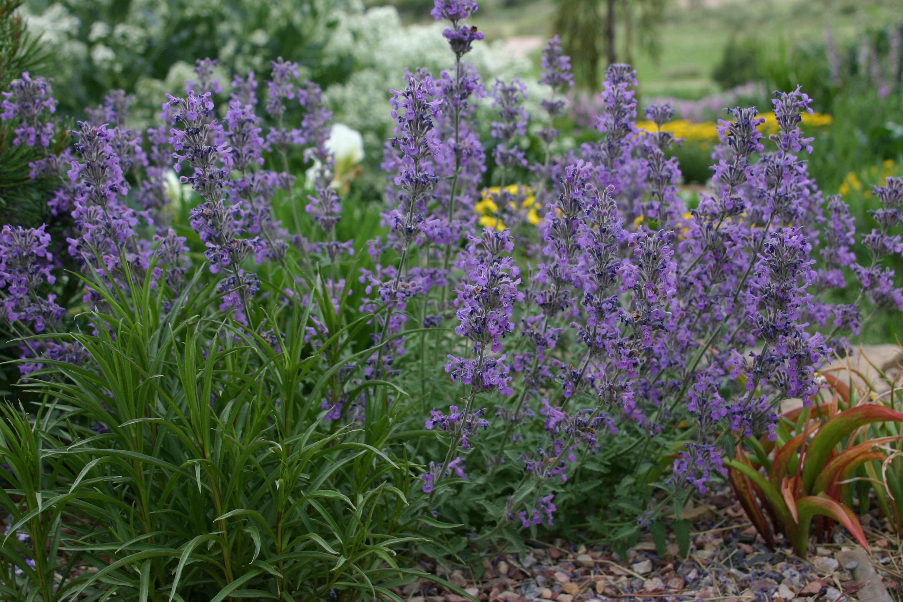
Height: 8-10”
Width: 12-16”
Blooms: April to October
Sun: Full sun to partial shade
Water: Moderate to xeric
Hardiness: USDA zones 4-9 (up to 8,000’)
Culture: Sandy, clay, or loamy soil
Recommended: 2008
Perennial
This hybrid catnip was selected at Little Valley Wholesale Nursery for its distinctive serrated, silvery foliage and long season of lavender bloom. It thrives under average or xeric conditions. It is the most compact catnip cultivar.

Little Trudy® Catnip
Nepeta ‘Psfike’ ^{PP18,904}
www.plantselect.org

