

**Little Trudy® Catnip**

*Nepeta ‘Psfike’* PP18,904

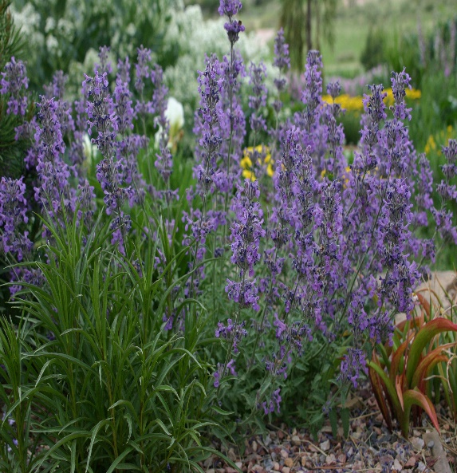



**Height: 8-10 in. Width: 12-16 in.**

This hybrid catnip was selected at Little Valley Wholesale Nursery for its distinctive serrated, silvery foliage and long season of lavender bloom. It thrives under average or xeric conditions. It is the most compact catnip cultivar.

**Culture:** Clay, loam or sandy soil

**Hardiness:** USDA zones 4-9



WIND. HAIL. SNOW. SUN

**BRING IT ON**

www.plantselect.org

