


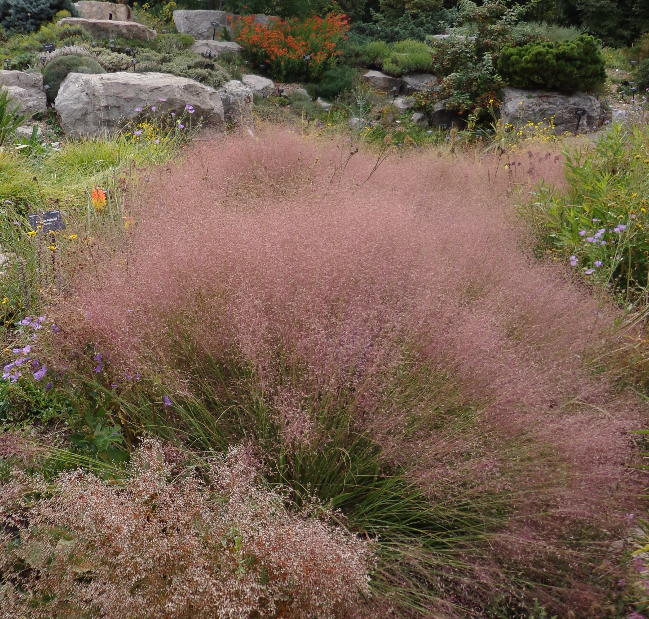
Height: 15-18”
Width: 18-24”
Blooms: Autumn
Sun: Full sun
Water: Moderate to dry
Hardiness: USDA zones 5-10
Culture: Clay or sandy soils
Introduced: 2014
Perennial Grass
Selection of long-lived grass brought from the southern Great Plains by Lauren and Scott Ogden. Graceful fine-textured gray-green mounds are topped by clouds of tiny ruby flowers that glow brilliantly when backlit in autumn. Persistent winter beauty, superb mass in plantings; also for accents and erosion control.

Undaunted® Ruby Muhly
Muhlenbergia reverchonii ‘PUND01S’
www.plantselect.org

