

**Undaunted® Ruby Muhly**

*Muhlenbergia reverchonii* ‘PUND01S’

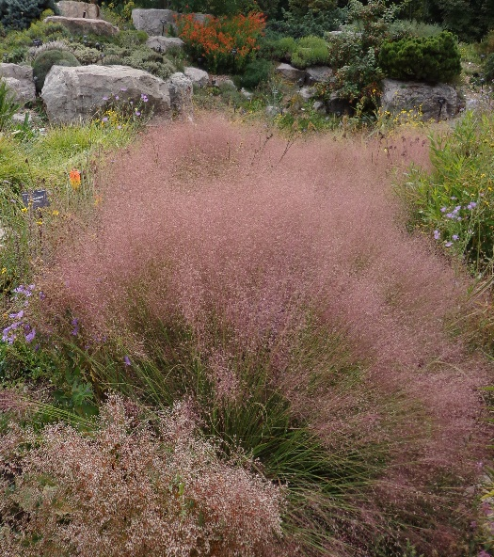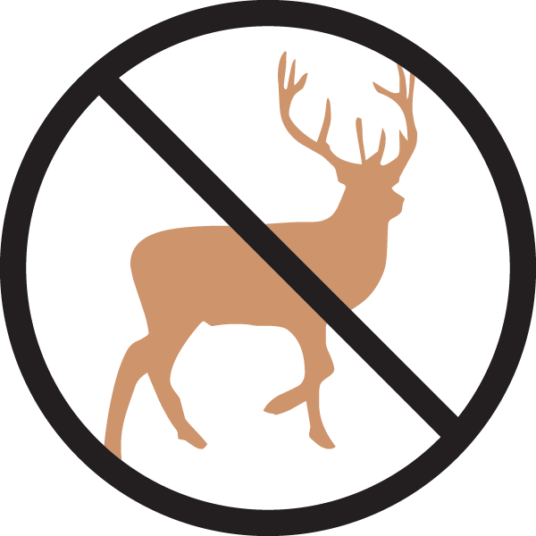

**Height: 16-20 in. Width: 18-24 in.**

Selection of long-lived grass brought from the southern Great Plains by Lauren and Scott Ogden. Graceful fine-textured gray-green mounds are topped by clouds of tiny ruby flowers that glow brilliantly when backlit in autumn. Persistent winter beauty, superb mass in plantings.

**Culture:** Clay or loam soil

**Hardiness:** USDA zones 5-10



WIND. HAIL. SNOW. SUN

**BRING IT ON**

www.plantselect.org

