
Hummingbird Trumpet Mint
Monardella macrantha ‘Marian Sampson’

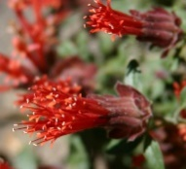





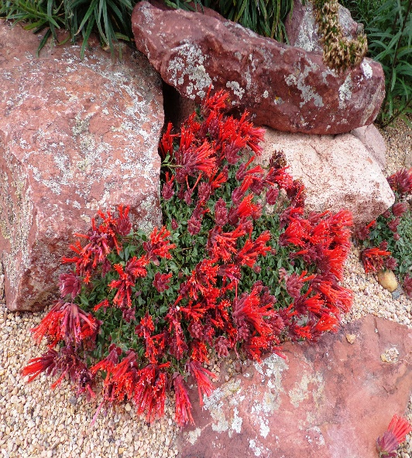

Height: 4-6 in. Width: 8-12 in.
Intensely aromatic herb forms low mounds of semi-evergreen leaves virtually hidden beneath exotic-looking clusters of brilliant scarlet-orange trumpets late spring through summer. Provide protection from heat of summer for best performance; may need winter protection in some areas.
Culture: Clay, loam or sandy soil
Hardiness: USDA zones 5b-9



WIND. HAIL. SNOW. SUN
BRING IT ON

www.plantselect.org



