

**Hummingbird Trumpet Mint**

*Monardella macrantha ‘*Marian Sampson’

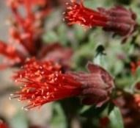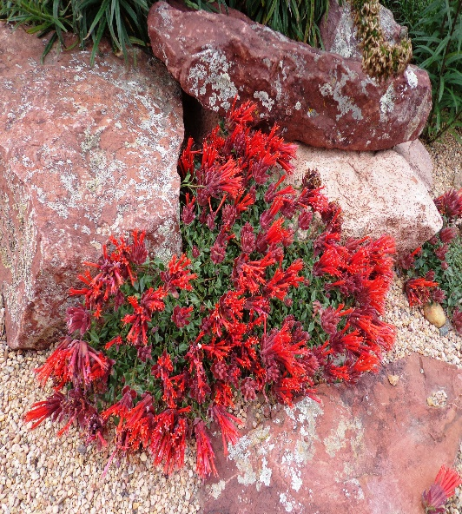

**Height: 4-6 in. Width: 8-12 in.**

Intensely aromatic herb forms low mounds of semi-evergreen leaves virtually hidden beneath exotic-looking clusters of brilliant scarlet-orange trumpets late spring through summer. Provide protection from heat of summer for best performance; may need winter protection in some areas.

**Culture:** Clay, loam or sandy soil

**Hardiness:** USDA zones 5b-9



WIND. HAIL. SNOW. SUN

**BRING IT ON**

www.plantselect.org

