
Pink Crystals® Ruby Grass
Melinis nerviglumis

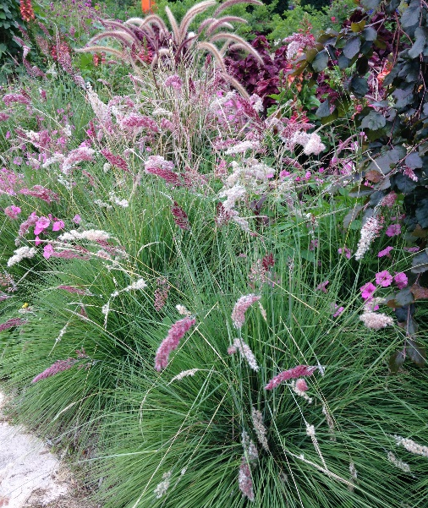





Height: 20-24 in. Width: 12-16 in.
Many gardeners consider the shimmering heads of bright ruby and silver flowers the most beautiful new contribution to bedding or the border. It sparkles like champagne bubbles. Great for containers.
Culture: Loam
Hardiness: Annual in USDA zones 4-6



WIND. HAIL. SNOW. SUN
BRING IT ON

www.plantselect.org



