

**Pink Crystals® Ruby Grass**

*Melinis nerviglumis*

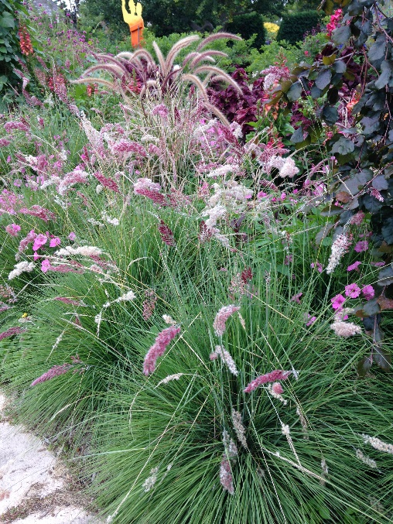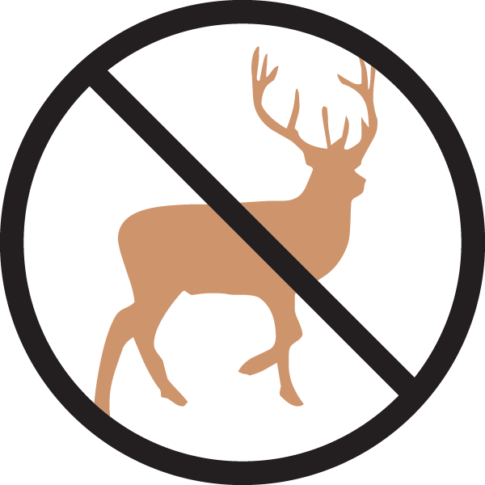

**Height: 20-24 in. Width: 12-16 in.**

Many gardeners consider the shimmering heads of bright ruby and silver flowers the most beautiful new contribution to bedding or the border. It sparkles like champagne bubbles. Great for containers.

**Culture:** Loam

**Hardiness:** Annual in USDA zones 4-6



WIND. HAIL. SNOW. SUN

**BRING IT ON**

www.plantselect.org

