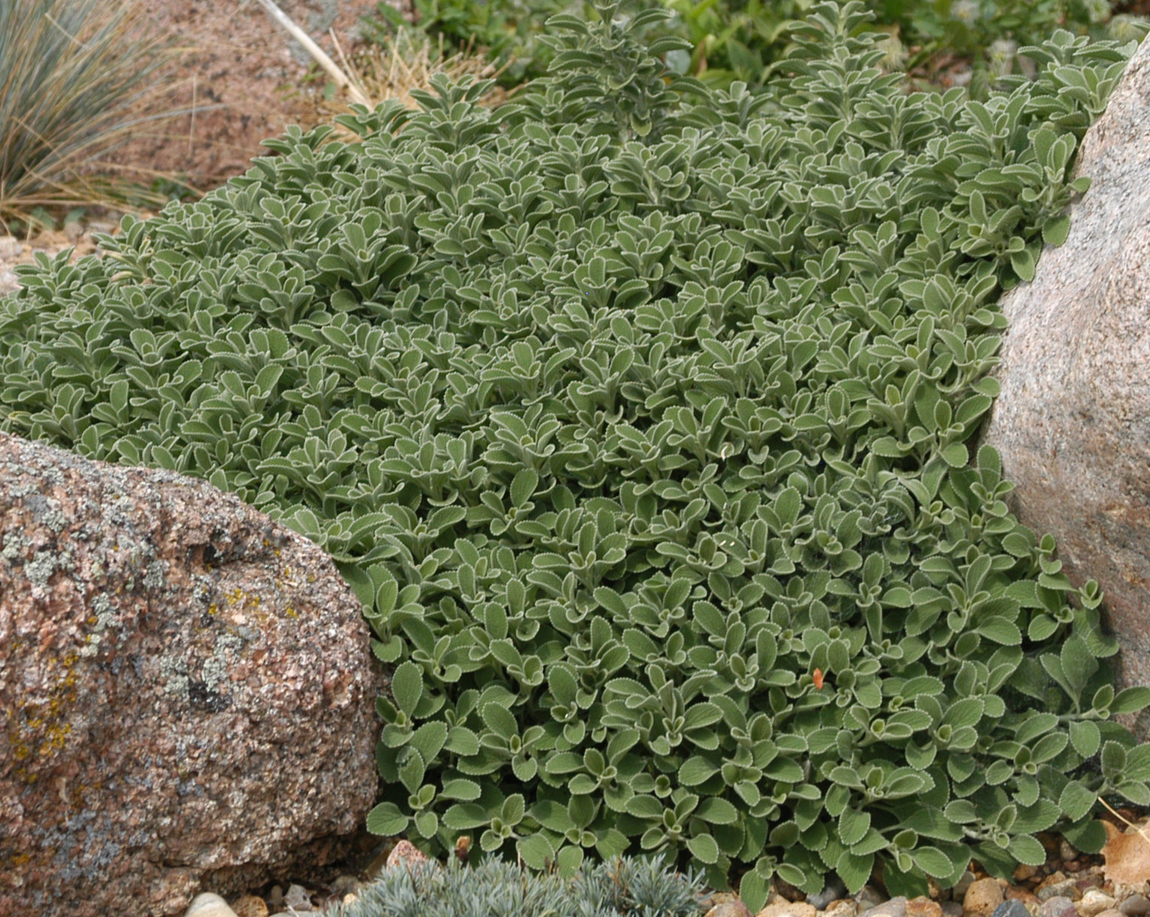



Height: 2-4”
Width: 24-36”
Blooms: Inconspicuous
Sun: Full sun
Water: Moderate to dry
Hardiness: USDA zones 4-9 (up to 8,000’)
Culture: Clay, sandy or loamy soil
Introduced: 2009
Perennial Groundcover
Vigorous mat-forming groundcover that thrives in many sites and soils. Bright silver lining shimmers on the fringes of rounded foliage. Native plant from Turkey.

Silverheels Horehound
Marrubium rotundifolium
www.plantselect.org

