

**Silverheels Horehound**

*Marrubium rotundifolium*

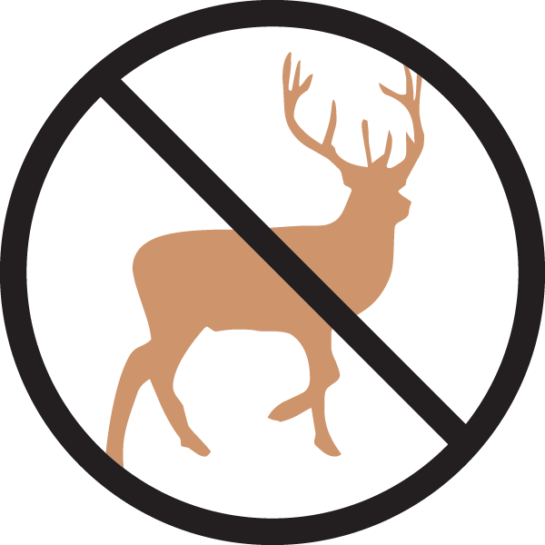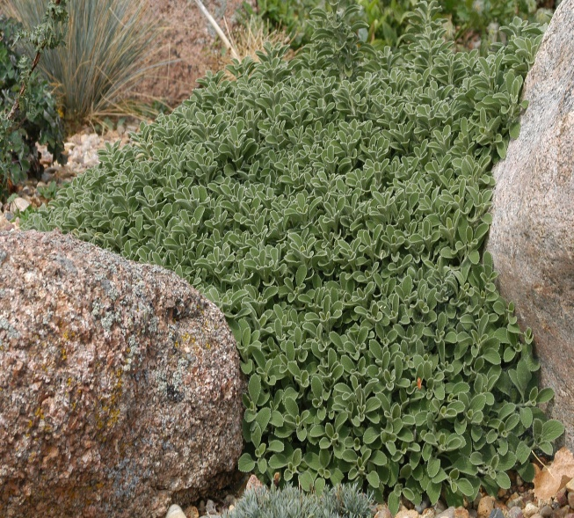

**Height: 2-4 ft. Width: 24-36 in.**

Vigorous mat-forming groundcover that thrives in many sites and soils. Bright silver lining shimmers on the fringes of rounded foliage. Native plant from Turkey.

**Culture:** Clay, loam or sandy soil

**Hardiness:** USDA zones 4-9



WIND. HAIL. SNOW. SUN

**BRING IT ON**

www.plantselect.org

