
Kintzley’s Ghost® Honeysuckle
Lonicera reticulata

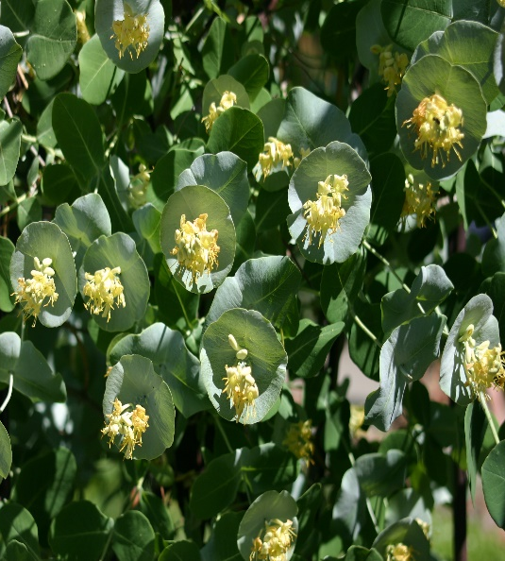



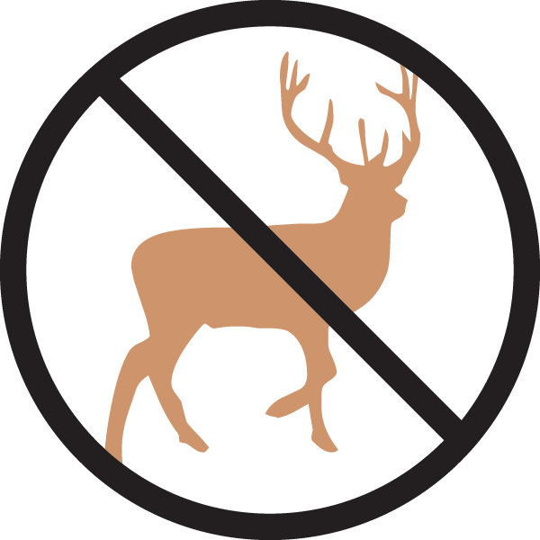



Height: 8-12 in. Width: 3-6 ft.
Vigorous vine clothed with long lasting, circular bracts the size and color of silver dollars, subtending tubular yellow flowers in spring. Ornamental red berries follow in late summer through winter.
Culture: Loam
Hardiness: USDA zones 4-8



WIND. HAIL. SNOW. SUN
BRING IT ON

www.plantselect.org



