

**Kintzley’s Ghost® Honeysuckle**

*Lonicera reticulata*

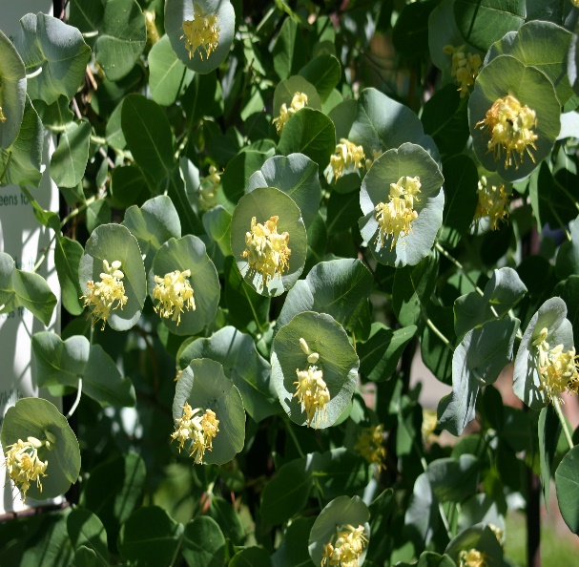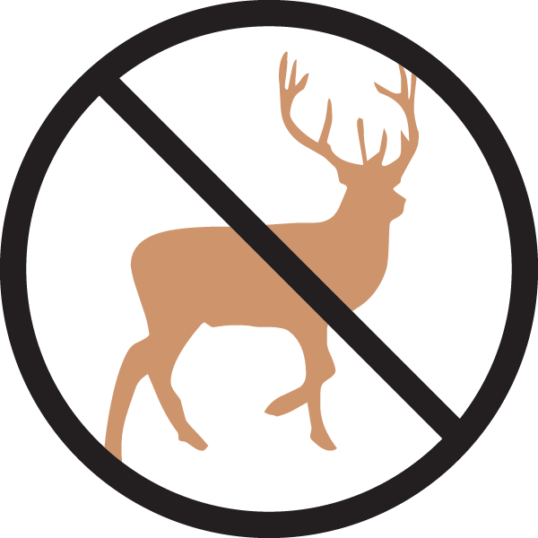

**Height: 8-12 in. Width: 3-6 ft.**

Vigorous vine clothed with long lasting, circular bracts the size and color of silver dollars, subtending tubular yellow flowers in spring. Ornamental red berries follow in late summer through winter.

**Culture:** Loam

**Hardiness:** USDA zones 4-8



WIND. HAIL. SNOW. SUN

**BRING IT ON**

www.plantselect.org

