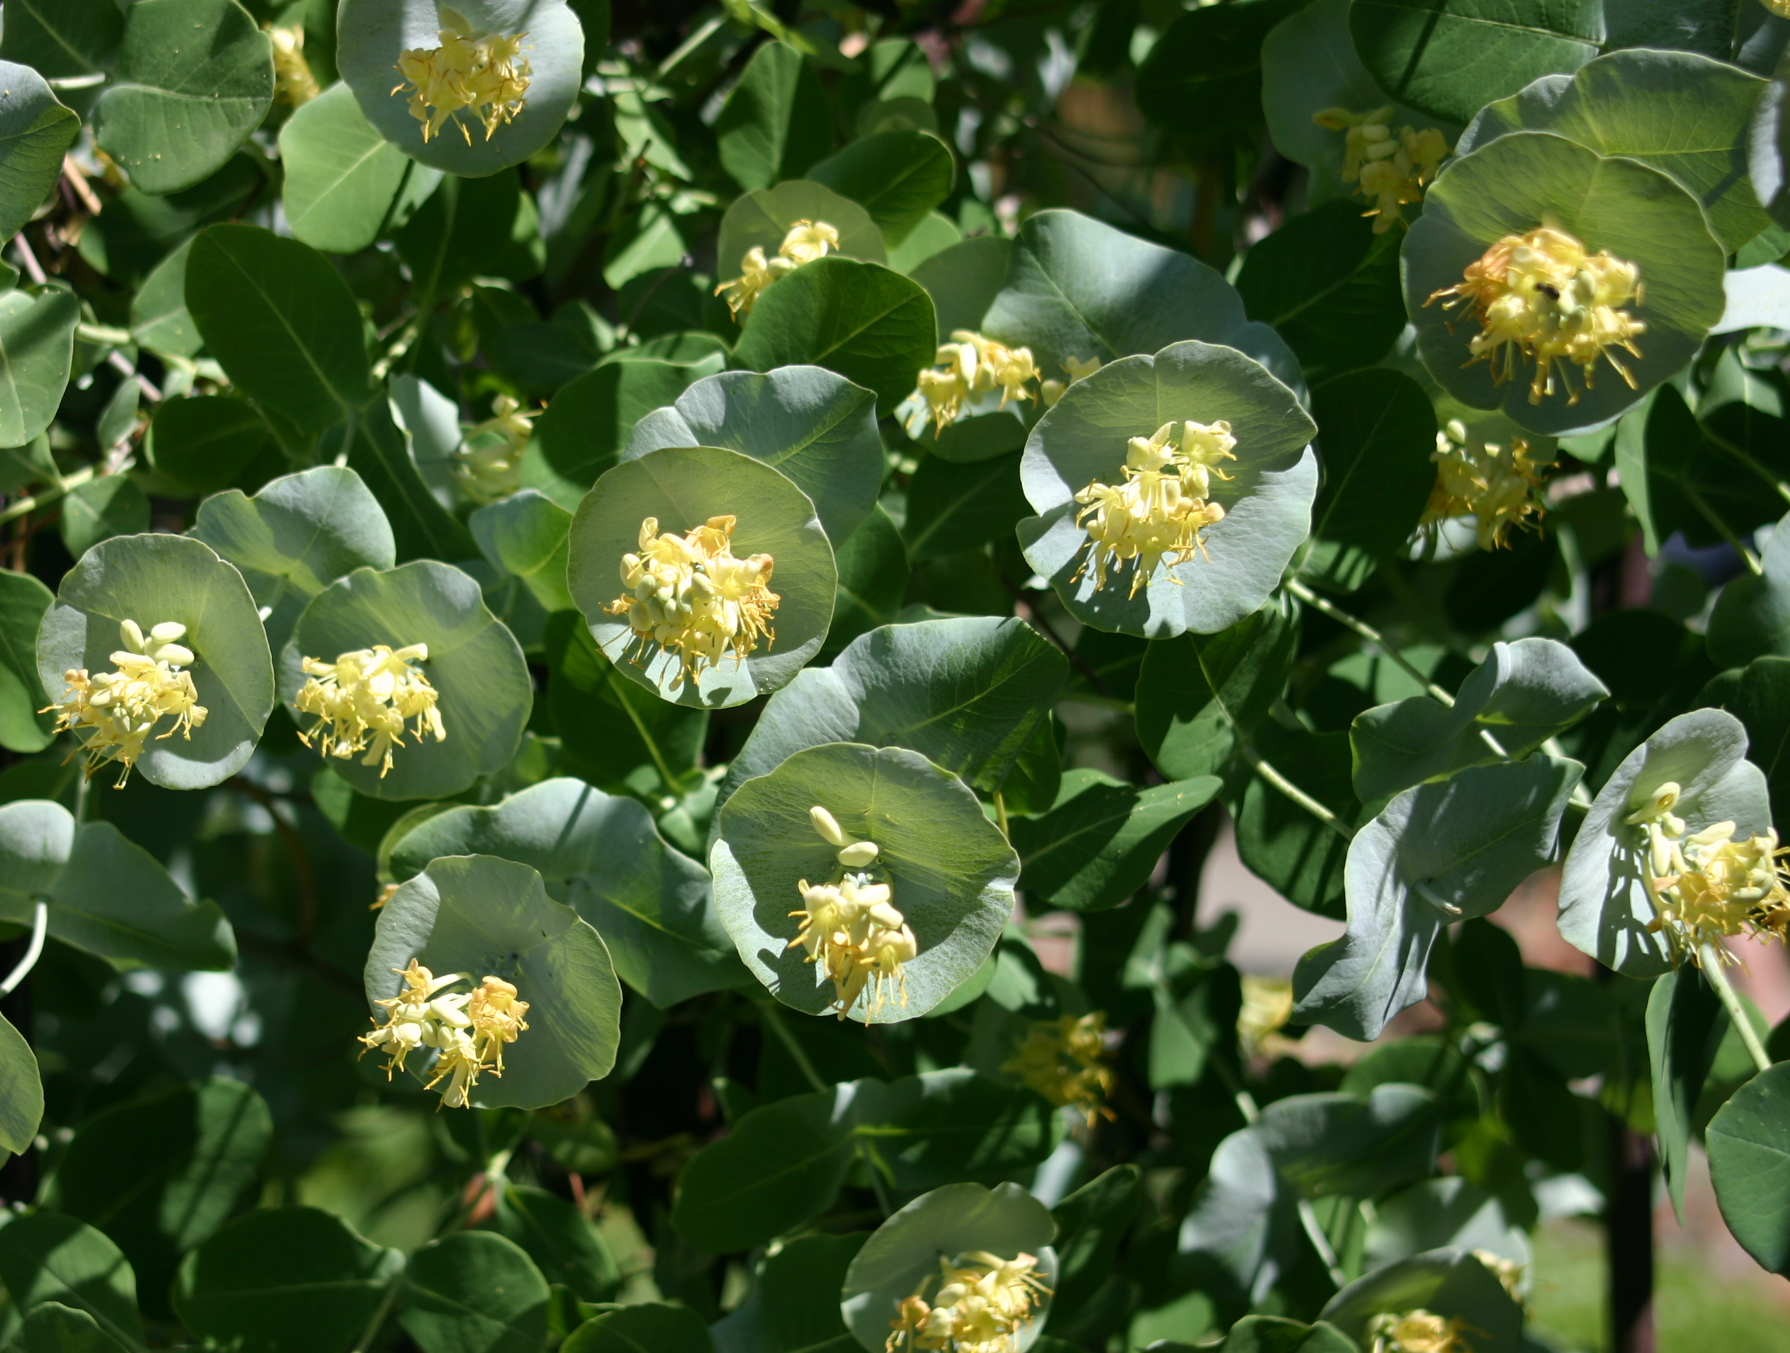



Height: 8-12’
Width: 3-6’
Blooms: Spring; showy bracts through fall
Sun: Full sun to partial shade
Water: Moderate
Hardiness: USDA zones 4-8 (up to 8,000’)
Culture: Average soil
Introduced: 2006
Vine
Vigorous vine clothed with long lasting, circular bracts surrounded by tubular flowers.

Kintzley’s Ghost® Honeysuckle
Lonicera reticulata
www.plantselect.org

