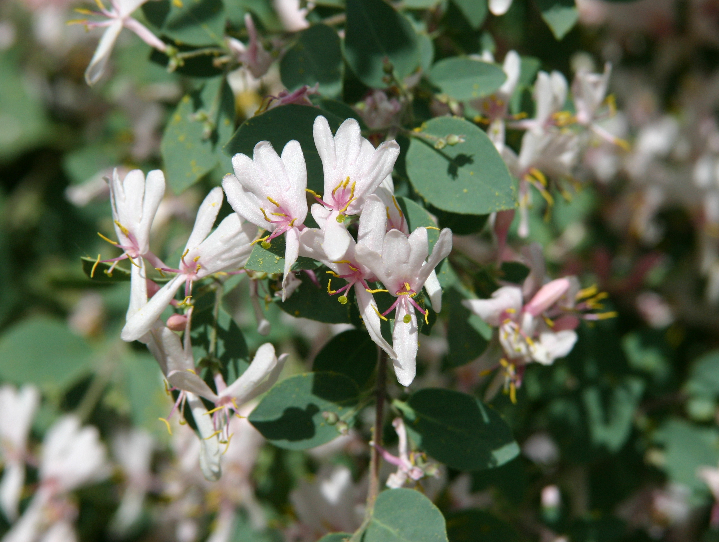

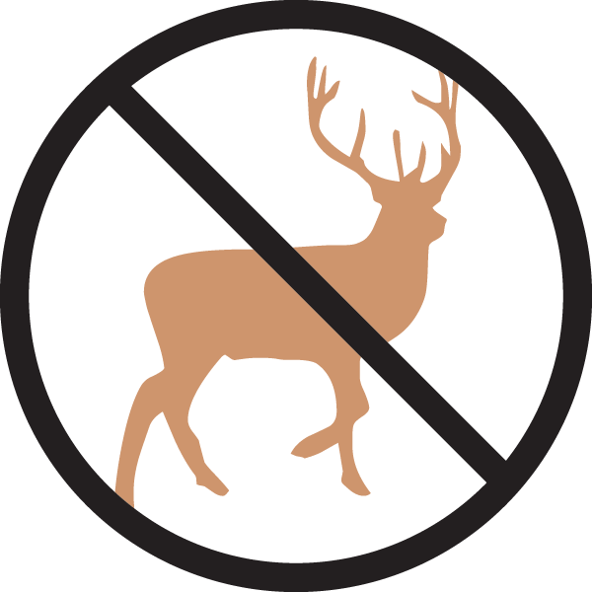

Height: 12’
Width: 8’
Blooms: Early spring
Sun: Full sun to partial shade
Water: Moderate to dry
Hardiness: USDA zones 3-8
Culture: Sandy soil or clay loam
Introduced: 1999
Shrub
Trim, round leaves on a stately blue-gray shrub. Opalescent pink flowers are showy in spring. Songbirds feed on the bright red berries as they ripen in summer and fall. Has proven resistant to disfiguring aphid damage. Drought tolerant once established.
.

Blue Velvet® Honeysuckle
Lonicera korolkowii ‘Floribunda’
www.plantselect.org

