

**Blue Velvet® Honeysuckle**

*Lonicera korolkowii* ‘Floribunda’

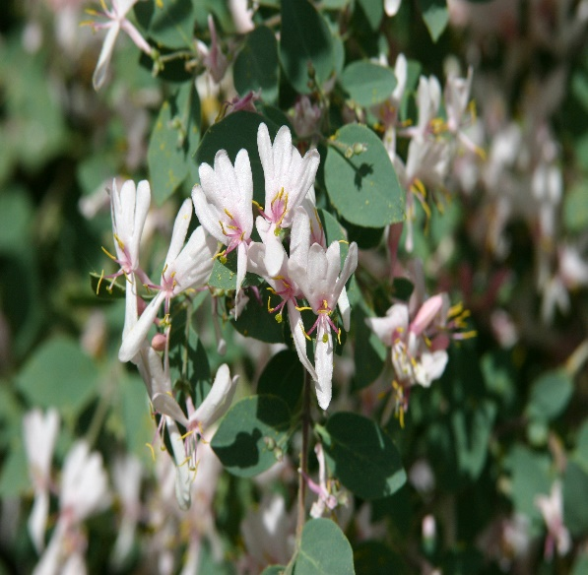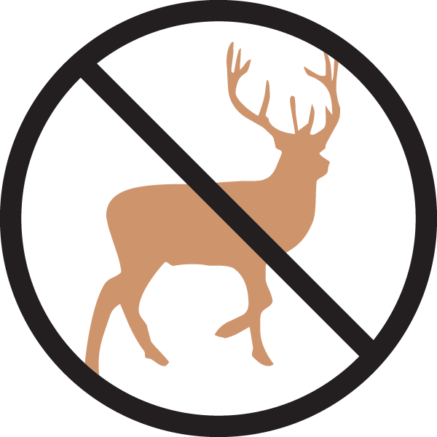

**Height: 10-12 ft. Width: 8-10 ft.**

Trim, round leaves on a stately blue-gray shrub. Opalescent pink flowers are showy in spring. Songbirds feed on the bright red berries as they ripen in summer and fall. Has proven resistant to disfiguring aphid damage. Drought tolerant once established.

**Culture:** Clay, loam or sandy soil

**Hardiness:** USDA zones 3-8



WIND. HAIL. SNOW. SUN

**BRING IT ON**

www.plantselect.org

