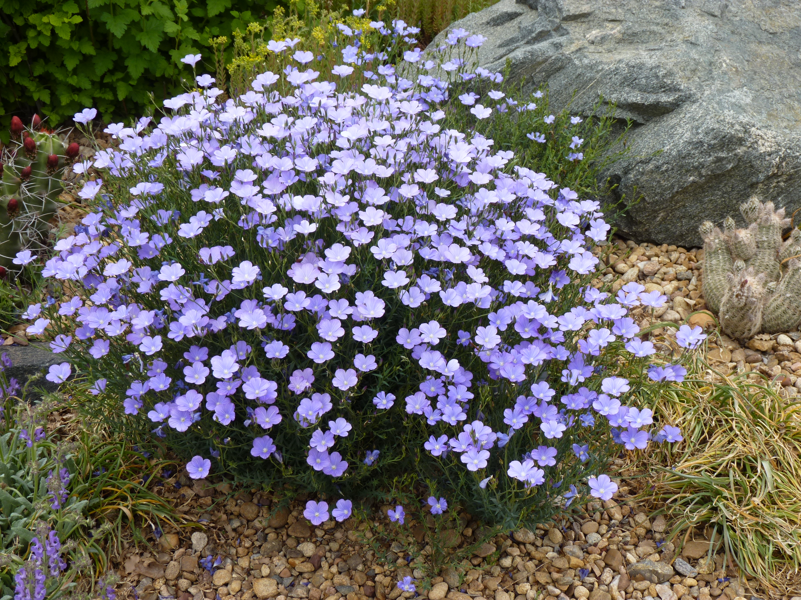



Height: 15-18”
Width: 15-18”
Blooms: May to July
Sun: Full sun to partial shade
Water: Moderate to xeric
Hardiness: USDA zones 5-8
Culture: Sandy or loam soil
Introduced: 2013
Perennial
Blooming for months on end, the deep sky blue flowers are larger and more flaring. This robust plant offers a dense mound of attractive, nearly evergreen foliage for garden borders, wildflower gardens and informal plantings.

Narbonne Blue Flax
Linum narbonense
www.plantselect.org

