
Narbonne Blue Flax
Linum narbonense

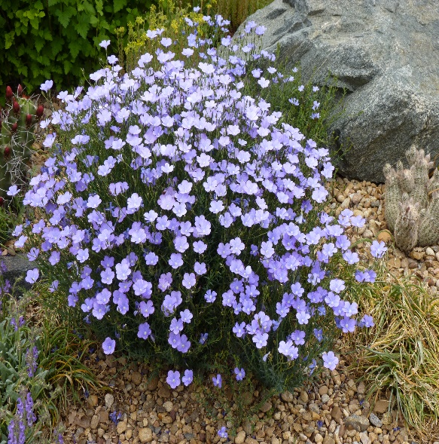



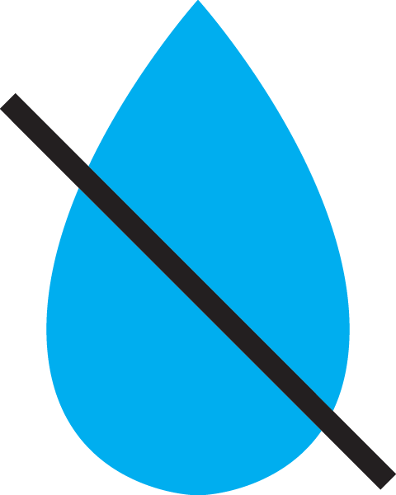

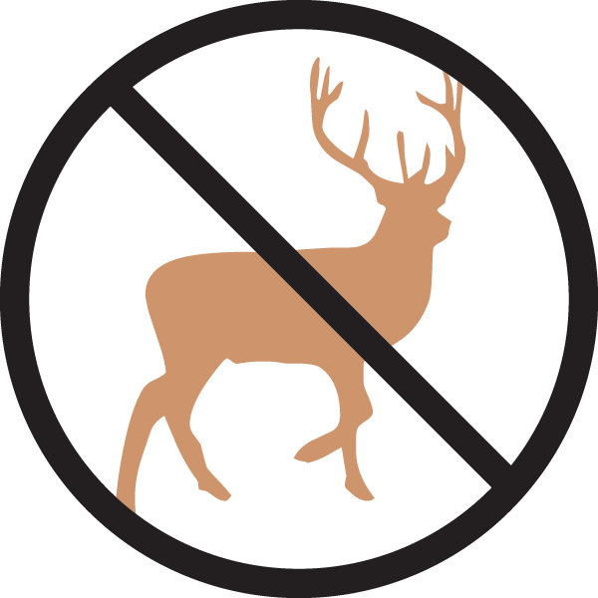

Height: 16-20 in. Width: 16-20 in.
Blooming for months on end, the deep sky blue flowers are larger and more flaring. This robust plant offers a dense mound of attractive, nearly evergreen foliage for garden borders, wildflower gardens and informal plantings.
Culture: Loam or sandy soil
Hardiness: USDA zones 5-8



WIND. HAIL. SNOW. SUN
BRING IT ON

www.plantselect.org



