

**Narbonne Blue Flax**

*Linum narbonense*

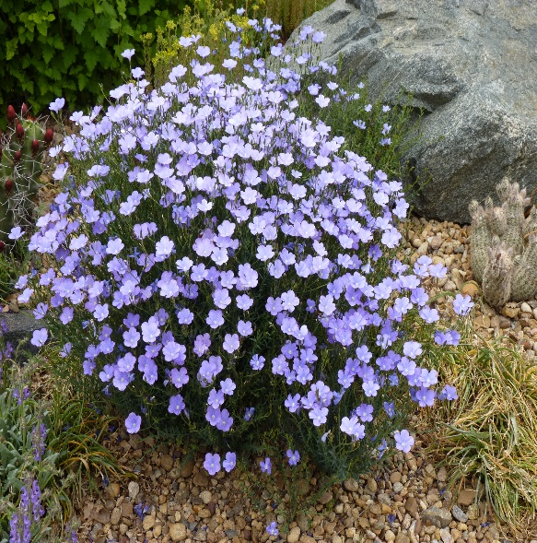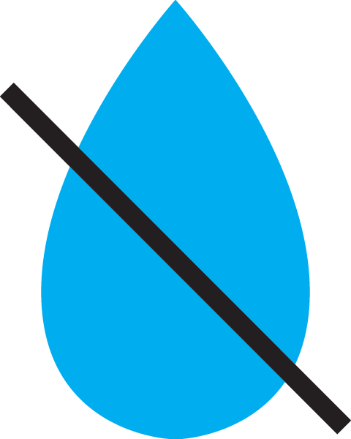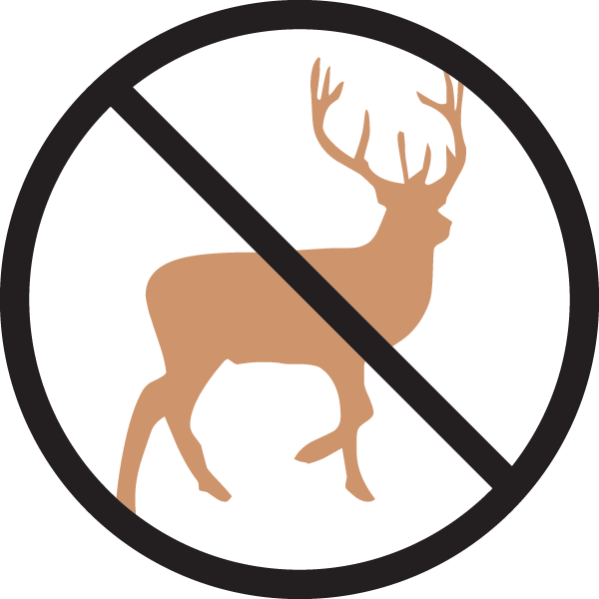

**Height: 16-20 in. Width: 16-20 in.**

Blooming for months on end, the deep sky blue flowers are larger and more flaring. This robust plant offers a dense mound of attractive, nearly evergreen foliage for garden borders, wildflower gardens and informal plantings.

**Culture:** Loam or sandy soil

**Hardiness:** USDA zones 5-8



WIND. HAIL. SNOW. SUN

**BRING IT ON**

www.plantselect.org

