

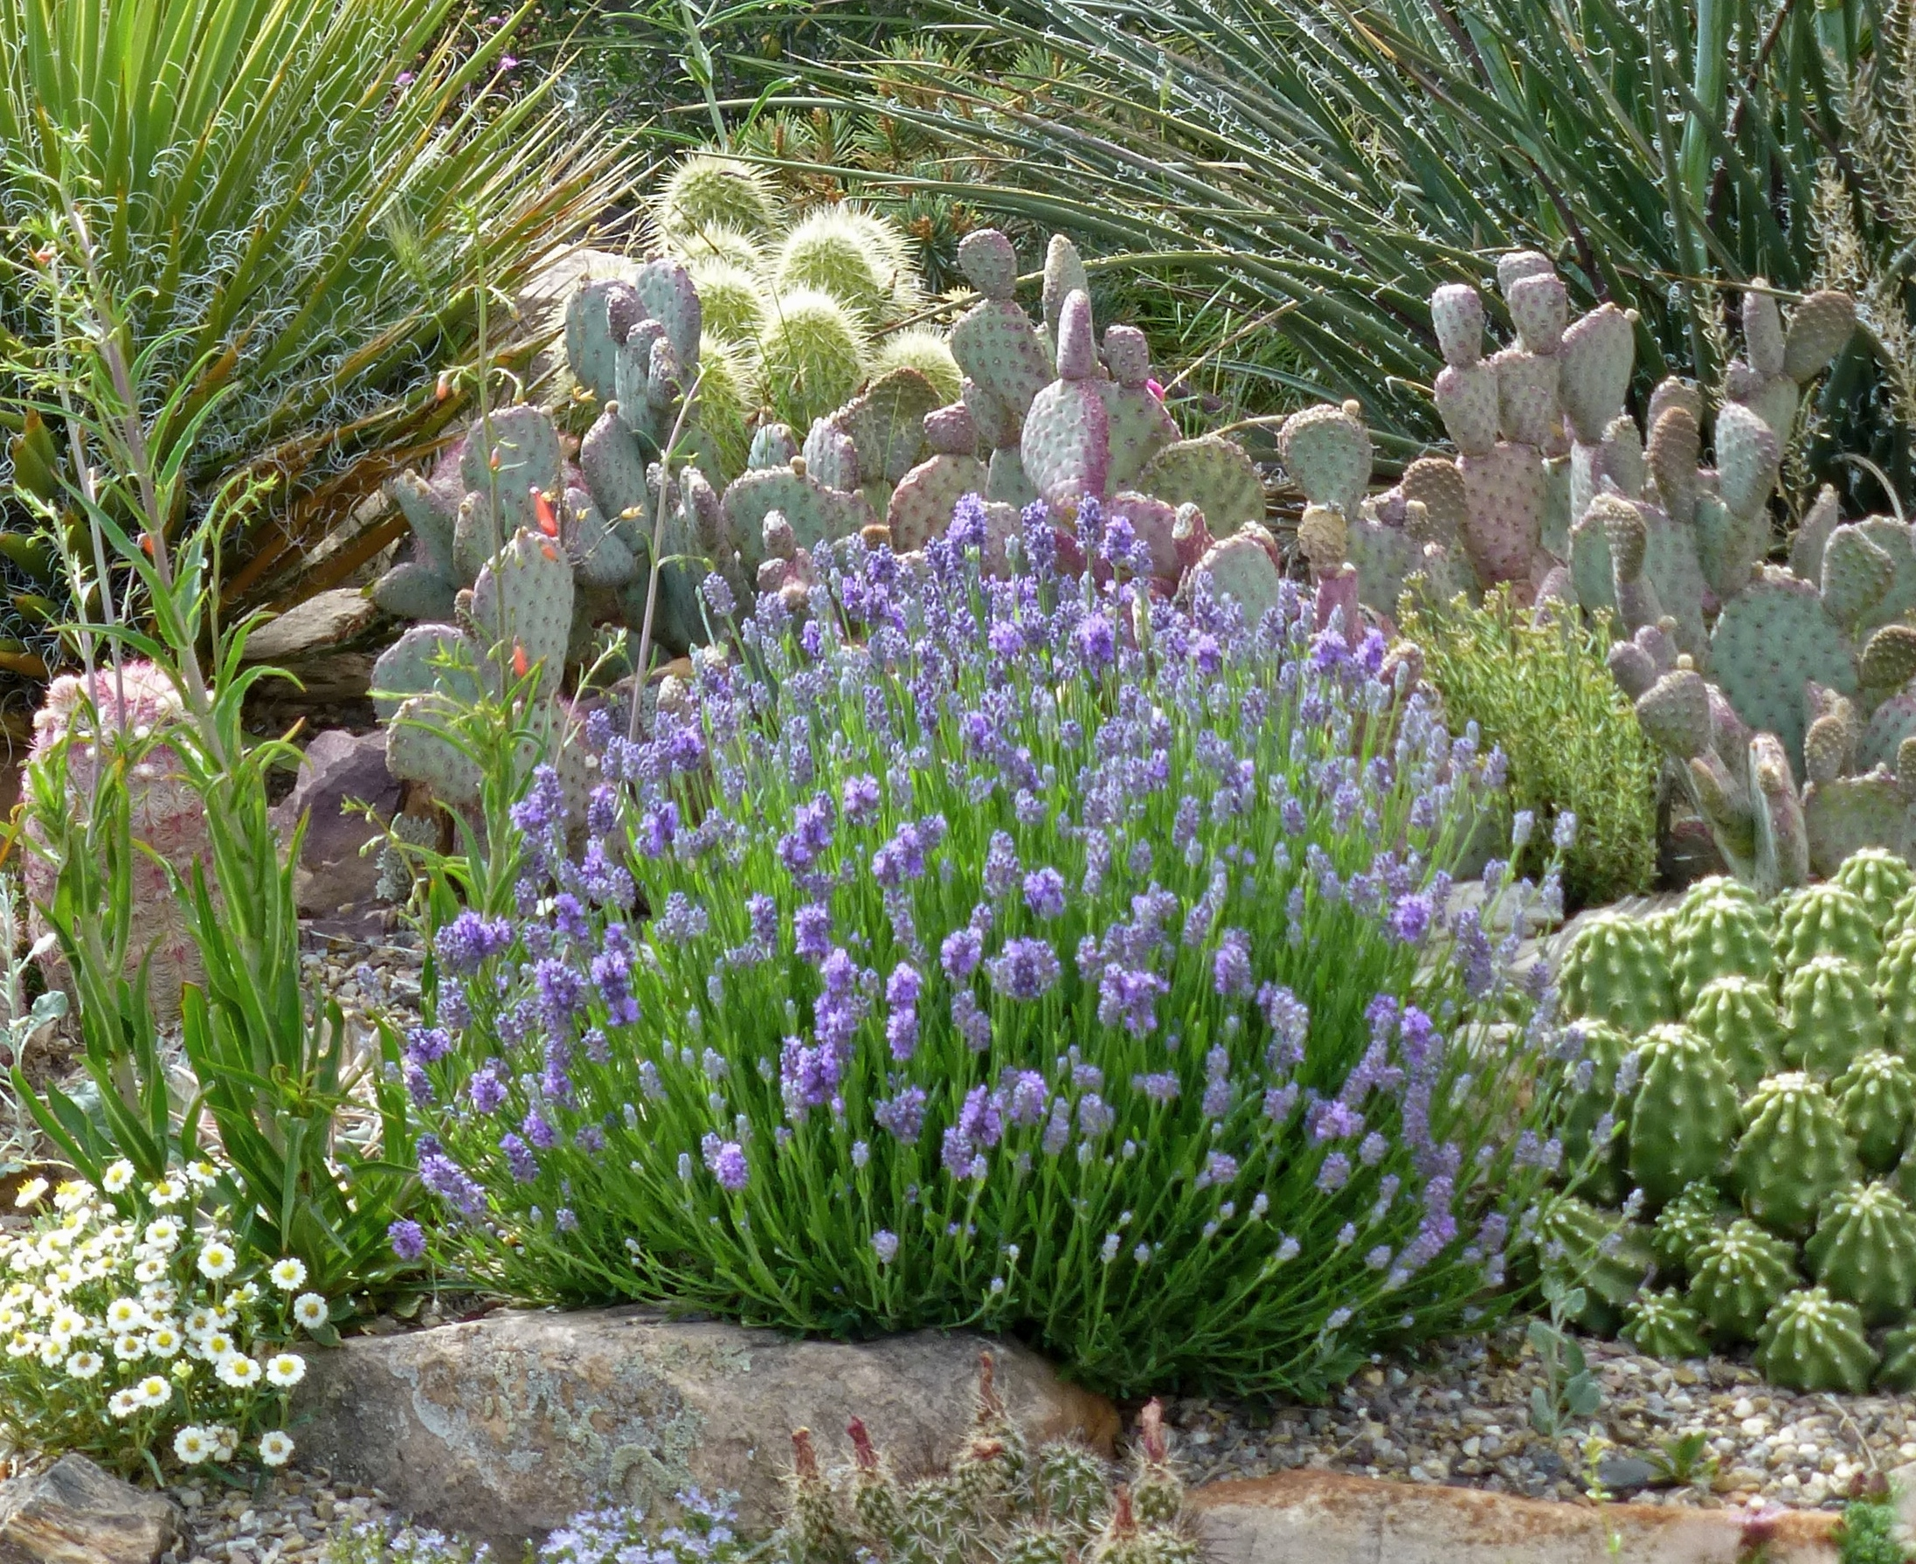

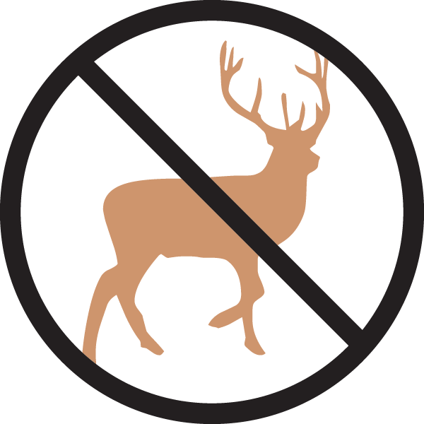
Height: 8-10”
Width: 12-15”
Blooms: Lavender, late spring
Sun: Full sun
Water: Dry to xeric
Hardiness: USDA zones 5-10
Culture: Loam or sandy soils
Introduced: 2017
Perennial
A wonderful dwarf English lavender with compact heads of lavender-blue flowers and dark blue calyxes, this tight growing little beauty is great for small spaces. In flower, it is only about 10" in height. Slow growing and very xeric, 'Wee One' has excellent heat tolerance and cold hardiness.

Wee One dwarf English lavender
Lavandula angustifolia ‘Wee One’
www.plantselect.org

