Wee One Dwarf English lavender
Lavendula angustifolia ‘Wee One’

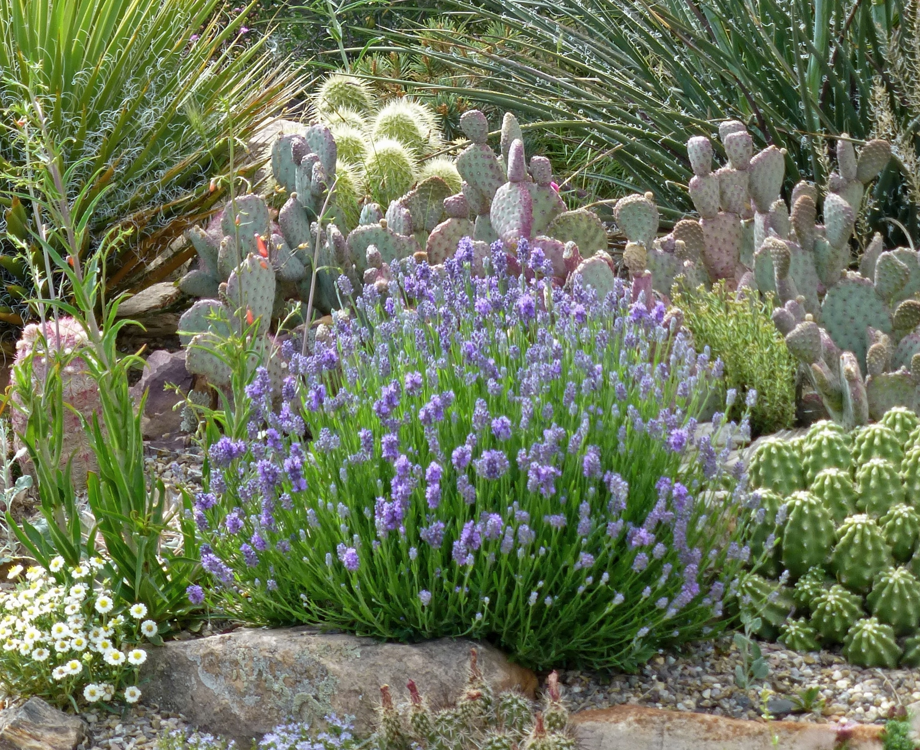





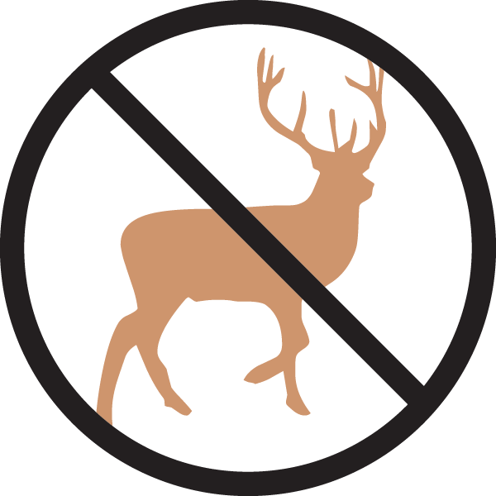

Height: 8-10 in.
Width: 12-15 in.
Hardiness: USDA zones 5-10
Culture: Loam or sandy soils
A wonderful dwarf English lavender with compact heads of lavender-blue flowers and dark blue calyxes, this tight growing little beauty is great for small spaces. In flower, the mature plant is only about 10" in height. Slow growing and very xeric, 'Wee One' has excellent heat tolerance and cold hardiness.

www.plantselect.org

