


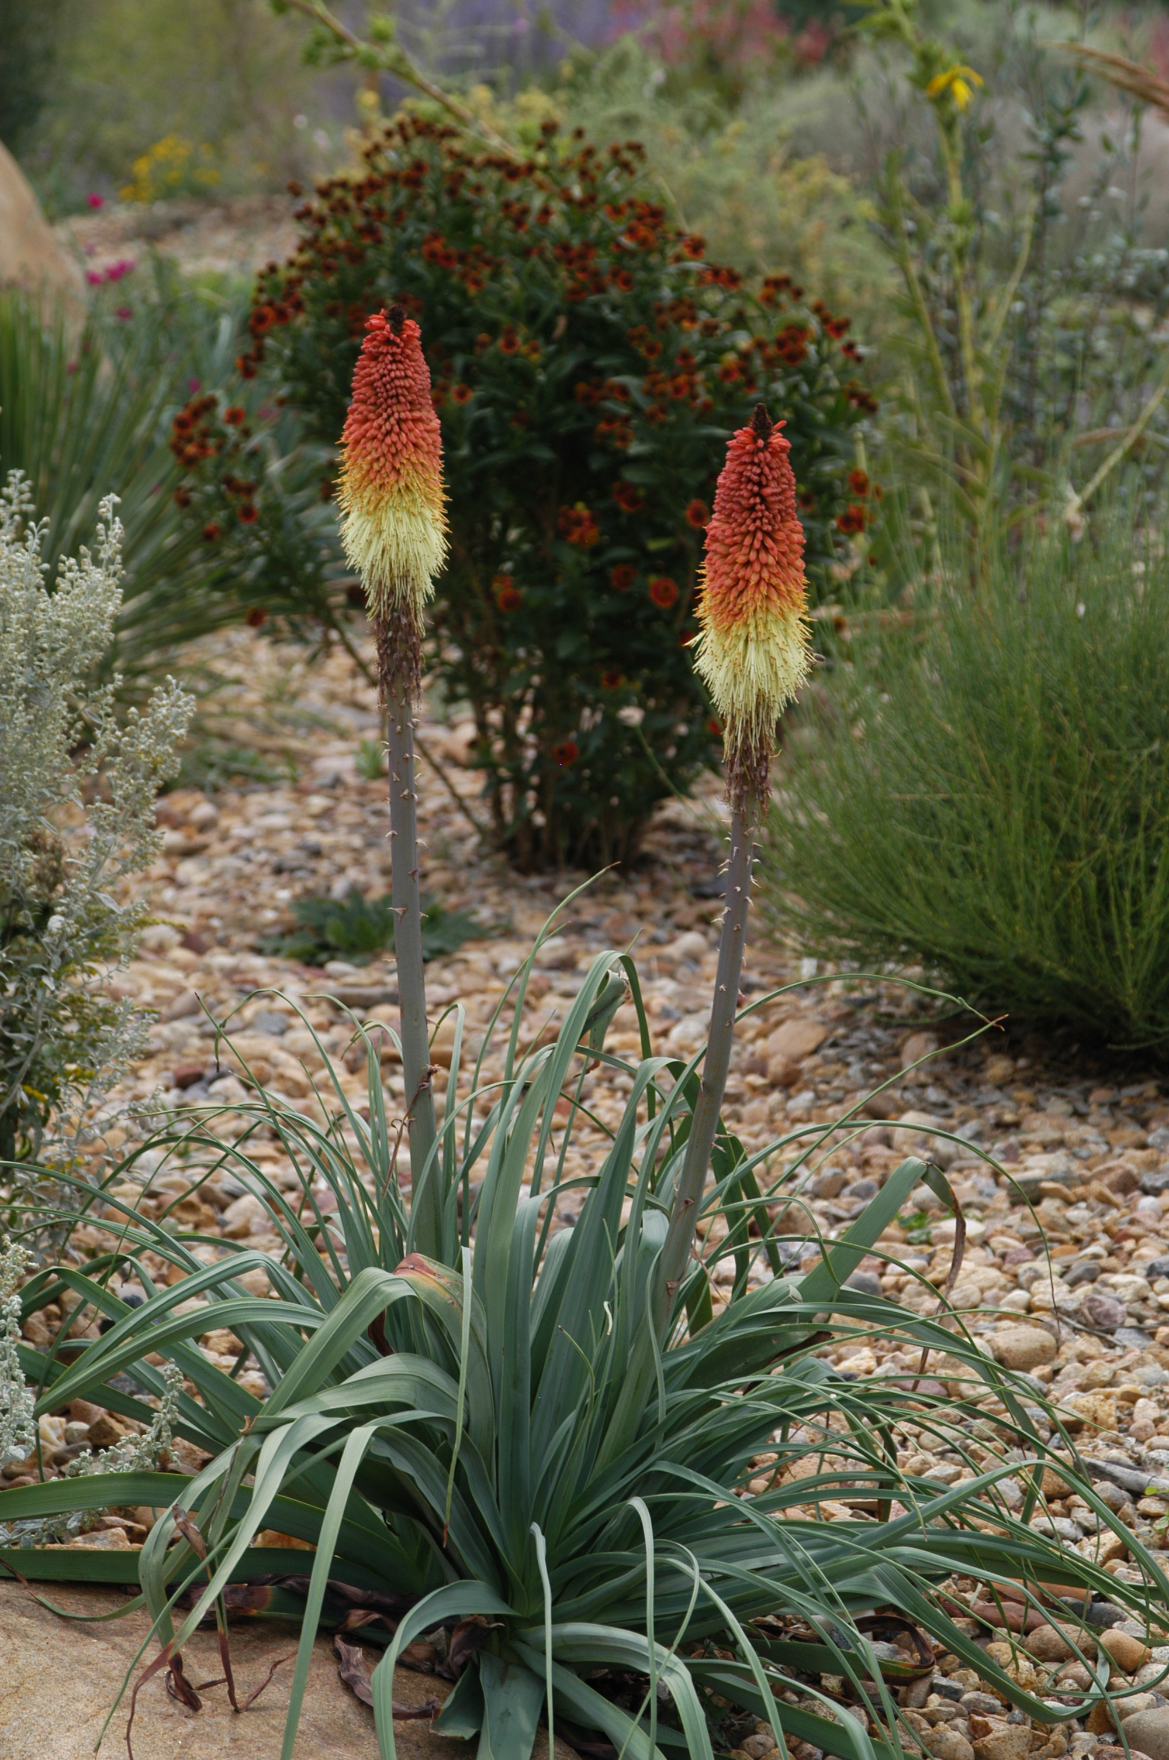
Height: 40”
Width: 24-30”
Blooms: Late July to September
Sun: Full sun to partial shade
Water: Moderate to dry; xeric
Hardiness: USDA zones 4b-9 (up to 7,000’)
Culture: Average soil
Introduced: 2010
Perennial
Gorgeous blue-green rosettes of foliage are garden worthy in their own right. By late summer the clump is crowned with glowing crimson, gold, and ivory torches that create a focal point in the border or xeriscape. One of the most versatile and showy of wild torch lilies, this promises to be a “must have” for all who see it.

Regal Torchilly
Kniphofia caulescens
www.plantselect.org

