
Regal Torchilly
Kniphofia caulescens

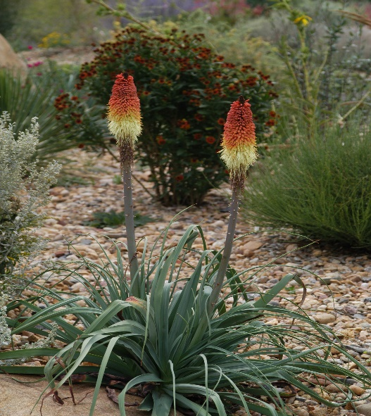




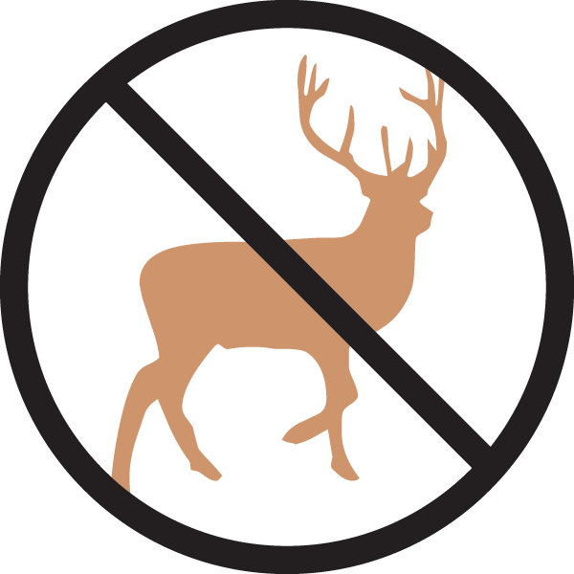

Height: 36-40 in. Width: 24-30 in.
Gorgeous blue-green rosettes of foliage are garden worthy in their own right. By late summer the clump is crowned with glowing crimson, gold, and ivory torches that create a focal point in the border or xeriscape.
Culture: Clay or loam or sandy soil
Hardiness: USDA zones 4b-9



WIND. HAIL. SNOW. SUN
BRING IT ON

www.plantselect.org



