

**Regal Torchilly**

*Kniphofia caulescens*

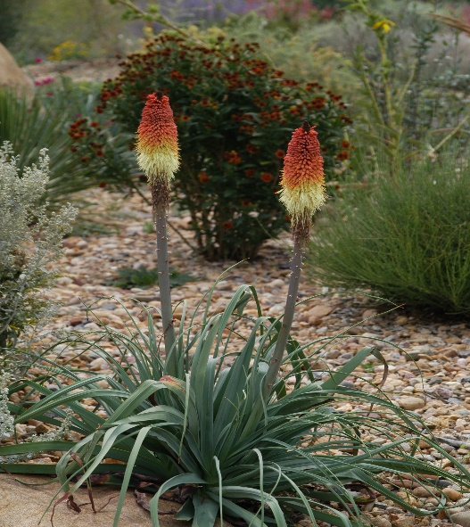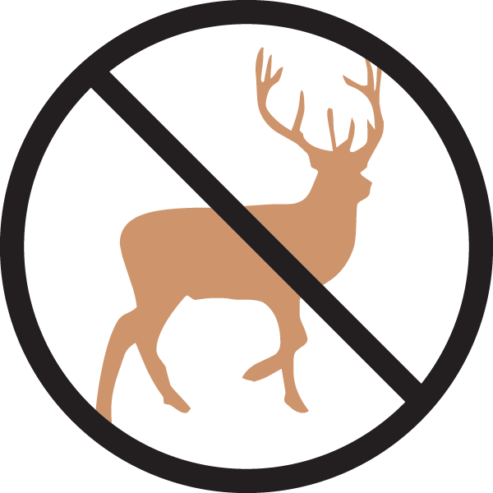

**Height: 36-40 in. Width: 24-30 in.**

Gorgeous blue-green rosettes of foliage are garden worthy in their own right. By late summer the clump is crowned with glowing crimson, gold, and ivory torches that create a focal point in the border or xeriscape.

**Culture:** Clay or loam or sandy soil

**Hardiness:** USDA zones 4b-9



WIND. HAIL. SNOW. SUN

**BRING IT ON**

www.plantselect.org

